**OBJECTIVES**

1. Assimilating various conceptual frameworks based on promotion and leadership development
2. To gain a deeper insight about the assessment methodology commonly used by organizations for promotion and development of employees
3. Analyzing the various assessment tools, their usefulness, benefits and limitations
4. Understanding the importance of assessment tools in general through various studies and research and in organizational context used for promotion and development which help in creating better future leaders
5. Analyzing the challenges faced during assessment of individuals for promotion and development

**INTRODUCTION**

Organizations are severely lacking the ability to identify and develop the right individuals for critical leadership roles. Our research shows, however, that strong assessments give organizations the clarity to select the best leaders for their business needs

*Frontline leaders are seen as the foundation for an organization’s success. Making up more than half of most companies’ management ranks, frontline leaders directly supervise a majority of the workforce. But whether organizations look to outside hiring or to internal promotions or development, they are failing to produce ready-now leaders.* The Global Leadership Forecast 2011 *found that only 33 percent of HR leaders are highly confident in their frontline leaders’ ability to ensure the future success of their organization.*

Succession Planning is the process of identifying one or more successors for key positions and preparing them for expanded organizational responsibilities through job assignments and other developmental activities.

***“Succession planning cannot take place in a vacuum. It should also be an intensive, comprehensive initiative, much more than a preparation of a list of names that will be tabled if the CEO is hit by a bus. Similarly, succession plans will not increase the productivity growth rate of the firm if they are designed only to allow the internal auditor to tick the box: succession plan in place.”***

***-***Paul Cantor, former Chairman, Russell Reynolds Associates Canada

Development of individual leaders (as opposed to organization development) is “the expansion of a person’s capacity to be effective in leadership roles and processes.

Interest in leadership development has exploded over the past decade as organizations look for ways to better address increased competitive pressures, respond quickly and flexibly to rapidly changing conditions,and innovate and exploit emerging technologies. It is thought that investments in leadership development pay off in terms of creating a sustained competitive advantage that will propel organizations forward in the 21st century economy.

*For example*, some estimates have placed the market value of General Electric at $20 billion higher than its breakup value, with much of that value attributable to the quality and depth of GE’s leadership capacity.

***“The people we hire, and the focus we put on their development as leaders, are critical to P&G ’s ability to innovate and compete. Nothing I do will have a more enduring impact on P&G’s long-term success than helping to develop other leaders.”***

-A.G. Lafley, CEO, Proctor & Gamble

In the following pages, we talk about a number of assessment techniques which are being used by organizations worldwide to assess the developmental needs of their organization and identify employees who are ready for promotion. Furthermore the report also describes some popular models which help understand Succession Planning and Leadership Development in greater detail.

**Evaluation and Selection of Assessment Tools:**

In selecting and evaluating an assessment tool, one must consider a number of important factors such as: (1) reliability, (2) validity, (3) technology, (4) the legal context, and (5) face validity/applicant reactions.

***Reliability.*** The term reliability refers to consistency. Assessment reliability is demonstrated by the consistency of scores obtained when the same applicants are re-examined with the same or equivalent form of an assessment. No assessment procedure is perfectly consistent. A goal of good assessment is to minimize random sources of error. As a general rule, smaller the amount of error, higher the reliability. Reliability is expressed as a positive decimal number ranging from 0 to 1.00, where 0 means the scores consist entirely of error. A reliability of 1.00 would mean the scores are free of any random error. In practice, scores always contain some amount of error and their reliabilities are less than 1.00. For most assessment applications, reliabilities above .70 are likely to be regarded as acceptable.

Reliability is very important when deciding which assessment to use for a given purpose. The test manual or other documentation supporting the use of an assessment should report details of reliability and how it was computed. The potential user should review the reliability information available for each prospective assessment before deciding which to implement. Reliability is also a key factor in evaluating the validity of an assessment. An assessment that fails to produce consistent scores for the same individuals examined under near-identical conditions cannot be expected to make useful predictions of other measures (e.g., job performance). Reliability is critically important because it places a limit on validity.

***Validity.*** Validity refers to the relationship between performance on an assessment and performance on the job. Validity is the most important issue to consider when deciding whether to use a particular assessment tool because an assessment that does not provide useful information about how an individual will perform on the job is of no value to the organization.

When multiple selection tools are used, you can consider the *combined* validity of the tools. To the extent the assessment tools measure different job-related factors each tool will provide unique information about the applicant’s ability to perform the job. Used together, the tools can more accurately predict the applicant’s job performance than either tool used alone. The amount of predictive validity one tool adds relative to another is often referred to as the incremental validity of the tool. The incremental validity of an assessment is important to know because even if an assessment has low validity by itself, it has the potential to add significantly to the prediction of job performance when joined with another measure. Just as assessment tools differ with respect to reliability, they also differ with respect to validity.

***Technology.*** The technology available is another factor in determining the appropriate assessment tool. Agencies that receive a large volume of applicants for position announcements may benefit from using technology to narrow down the applicant pool, such as online screening of resumes or online biographical data (biodata) tests. Technology can also overcome distance challenges and enable agencies to reach and interview a larger population of applicants.

However, because technology removes the human element from the assessment process, it may be perceived as “cold” by applicants, and is probably best used in situations that do not rely heavily on human intervention, such as collecting applications or conducting applicant screening. Technology should not be used for final selection decisions, as these traditionally require a more individualized and in-depth evaluation of the candidate.

***Legal Context of Assessment.*** Any assessment procedure used to make an employment decision (e.g., selection, promotion, pay increase) can be open to claims of adverse impact based on subgroup differences. Adverse impact is a legal concept used to determine whether there is a “substantially different” passing rate (or selection rate) between two groups on an assessment procedure. Groups are typically defined on the basis of race (e.g., Blacks compared to Whites), gender (i.e., males compared to females), or ethnicity (e.g., Hispanics compared to Non-Hispanics). Assessment procedures having an adverse impact on any group must be shown to be job-related (i.e., valid).

***Face Validity/Applicant Reactions.***When applicants participate in an assessment process, they are not the only ones being evaluated; the agency is being evaluated as well. Applicants who complete an assessment process leave with impressions about the face validity and overall fairness of the assessment procedure. Their impressions can also be impacted by whether they believe they had a sufficient opportunity to display their job-related competencies. The quality of the interactions between the applicant and agency representatives can also affect applicant reactions. Agencies using gruelling assessment procedures may end up alienating applicants. It is important to recognize applicants use the assessment process as one means to gather information about the agency. Failure to act on this fact can be very costly to agencies, particularly if top candidates are driven to look elsewhere for employment opportunities.

# LITERATURE REVIEW

**Why succession planning and leadership development are crucial concerns**

In the SHRM foundation report authored by David V. Day, the following reasons are mentioned as reasons why succession planning and leadership development are crucial concerns:

1. ***Speed of change*** is increasing, and the ***type of change*** that organizations experience is likely to be radical and discontinuous. This argues for greater shared leadership in organizations. Shared leadership supports more effective change management in terms of both sensing needed organizational changes and building momentum for change more quickly than relying on a single change leader.
2. ***Complexity in the challenges*** faced by organizations across most industry sectors is increasing exponentially. This has resulted in the heightened feeling of “vujade” (as compared with déjà vu)—I have never been here before, I have no idea what is happening, and I don’t know who can help me. Such complexity typically exceeds the capacity of any single leader to make sense of and develop workable solutions.
3. ***Task migration*** occurs whereby traditionally higher-level leadership responsibilities are transferred to leaders at lower levels. This is partly a function of the trend toward redesigning flatter organizations in which greater leadership gaps become apparent, but it is also due to greater speed and complexities of challenges. What was typically handled by senior leaders in the past has been handed down to junior leaders so the former can focus on even more complex issues.
4. ***Recruitment and retention*** are tied to issues associated with whether employees feel that their professional potential is being developed and used in the best possible way. Having opportunities across the organizational spectrum to participate in leadership development efforts is something that can provide an incentive to join and remain with an organization.

**Key Aspects of an Effective Succession Management and Leadership Development System**

In the same report, the author also talks about the key aspects of an Effective Succession Management and Leadership Development System:

1. ***Formal:*** A formal process is one in which the key pieces are standardized throughout an organization. An informal process occurs in an unplanned and ad-hoc manner. There is a risk of succumbing to informal; ad-hoc development approaches that place the entire burden for development onto the individual employee. While it is important for employees to accept final responsibility for their development as leaders, without a formal process that links experiences with expected developmental outcomes, there is no oversight in terms of what is being developed and when. The use of informal succession planning processes also risks wasting time and money in terms of potentially developing the wrong things in the wrong people. Informal often means reactive and opportunistic. Formal systems require organizational discipline to design, implement and sustain. The result can be instrumental in buffering an organization from succession surprises, and it can be a source for competitive advantage in other ways (e.g., recruitment, adaptability).
2. ***Systemic:*** An overall systems wide perspective on leadership development helps to build a broader leadership capacity and a deeper pipeline of leaders. The focus is not just on those at the top but includes most or all management levels. There is a related tendency to focus attention on high-potential employees. This makes sense in terms of potentially maximizing the return on investment (ROI) from developmental efforts.
3. ***Systematic:*** The most effective succession planning and leadership development initiatives are connected across levels into a coherent whole. There is a roadmap for development such that the skills, competencies, attitudes and perspectives that are developed at one level are built upon at a higher level. By being systematic, the development initiative builds explicit linkages across leadership levels. Succession planning also incorporates diagnostic tools and methods for assessing the developmental readiness of employees for particular experiences.
4. ***Tailored:*** Overly generic leadership development initiatives lose sight of the universal importance of individual differences in developmental readiness. People differ in the extent that they are ready for developmental “stretch” assignments that are at the core of many of the most effective leadership development initiatives. For example, When it comes to succession management, Jack Welch was probably the best known CEO-champion of tailored succession management. His Chief Learning Officer at the time (Steve Kerr) claimed that Welch “knows intimately” the career paths of more than a thousand employees in GE and would spend fully one quarter of his time on the GE succession planning process known as *Session C*. This level of CEO involvement in succession planning is extraordinary and probably unlikely in most other organizations. At minimum, however, every managerial employee should have an individual development plan and be held accountable for making progress on it every year.
5. ***Experientially based:*** Leadership development is not a discrete event.Rather, it is a significant part of ongoing work-related experience. Research shows that executivesfind learning from work-related experience to be a more powerful force for their development as compared with classroom-based learning. State-of-the-practice development focuses onhelping leaders learn and develop from their work experiences rather than taking them away from their work to develop.

**Succession Planning Process Continuum**

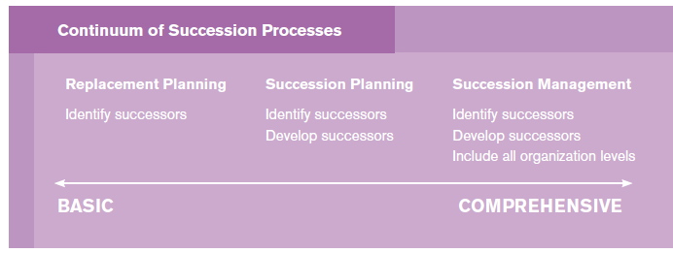

Succession management helps to provide continuity in the leadership pipeline and to develop a deeper capacity for leadership and performance. But to implement an integrated and effective succession management process there first needs to be an explicit link drawn between what the organization values as talent and the core strategies of that organization. After this has been accomplished (which is no mean feat), an honest and thorough evaluation of the organization’s talent pool and developmental needs is conducted. Although it might be tempting to jump right into a succession management process, there are key questions that first need to be answered.

**Succession Planning Process:**

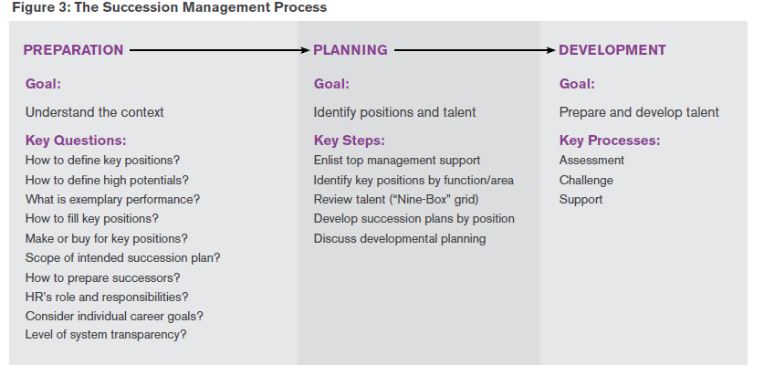

**Key questions impacting the design of Succession Planning Model**

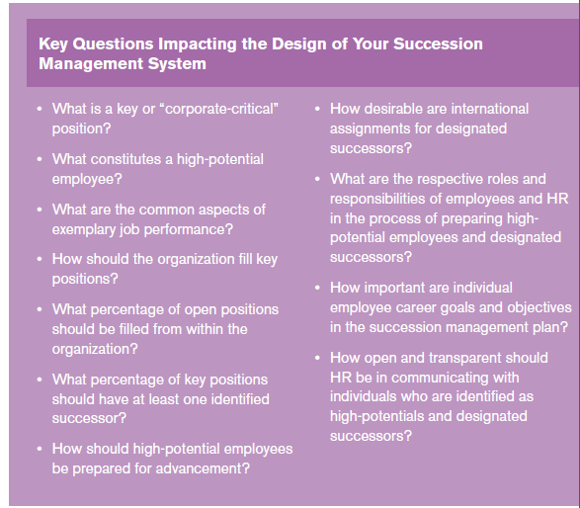

**Research on succession management**

Recent descriptive research examines the prevalence of succession planning in organizations as well as HR’s role in the succession planning process. In terms of prevalence, the good news is that more than half of the survey respondents (58 percent) indicated that they had some kind of a succession plan in place. The bad news is that this percentage was split equally (29 percent each) between those with a formal and those with an informal succession plan, with smaller organizations indicating that their processes were more likely to be informal rather than formal. This is bad news because the report findings also document that in comparisons across organizations with formal and informal succession plans, those with formal plans were more likely to:

* Identify employees who could potentially fill future vacancies in leadership positions.
* Consider the organization’s long-term objectives and goals.
* Identify prospective vacancies in leadership positions.
* Identify potential succession gaps.
* Integrate succession planning with the organization’s strategic planning process.
* Emphasize diversity in the workplace.
* Include a specific focus on the succession of women candidates.
* Update employees on the steps the organization plans to use in the succession planning process.

There are three noteworthy implications from these specificfindings. Those organizations with formal succession planning are more likely than those with informal planning to

(1) Be more proactive in identifying and developing their leadership talent;

(2) Be more attuned to diversity issues; and

(3) Have a more transparent succession planning process.

Another notable finding from the survey results is the time frame for the future skills considered insuccession plans. Of those reporting havingeither a formal or an informal plan in place, 84 percent considered skills that would be needed one year in advance, 76 percent consideredskills that would be needed two years in advance, and 62 percent considered skills what would beneeded three years in advance. But this percentage drops to under half for projecting four (47 percent) and five (44 percent) years in advance and plummets to 14 percent whenthe time frame is six years out.

**Obstacles to successful succession management**

Ultimately, an investment in succession management is an investment in individual and organizational learning. But like many things, this is easier said than done. There are many potential factors that can derail a succession management process. Here is a brief list and discussion of some of the most likely culprits-

1. ***Event-based or episodic thinking*:** This one plagues succession planning as well as leadership development. Succession planning typically is conducted only once a year, and leadership development is treated as a series of “loosely coupled” events or episodes, usually in the form of programs. Some of the most potent forms of development are embedded in the actual work (e.g., action learning, job assignments). It is a mistake to try to completely de-couple development from work.
2. ***No strategy for development*:** Whatis the organization’s philosophyof leadership and development?These are key concerns in termsof presenting and defining theconcepts and principles thatwill serve as the pillars of theconceptual framework for theinitiative.
3. ***Assuming it is solely a stafffunction*:** In many cases, theHR function has the primaryresponsibility for successionmanagement. A common mistakeand typical obstacle to effectiveimplementation is failing toengage line management from theoutset.
4. ***Over-embedding the initiativein a single champion*:** Having achampion, especially at top levels,is an important driver for success;however, if the initiative becomestoo heavily associated with anyone person—no matter howhigh-ranking—this could lead tofollow-through problems if thatchampion derails or leaves theorganization.
5. ***Not connecting with strategicbusiness imperatives*:** Developmentfor development’s sake might bea generally good thing; however,it is not helpful for long-termsupport. It is easy to lose sightof what specifically needs tobe developed and why. If thetarget of development activitiesis supposed to be leadershipcompetencies, then there shouldbe a visible and widely agreedupon competency model that isgrounded in the organization’s strategic business plan.
6. ***Under-emphasizing personalaccountability*:** The ultimateresponsibility for developmentrests with the individual leader.Only so much can be donein any development programor initiative. There should bepersonal accountability andfollow-up so that learning anddevelopment become intentionalprocesses that occur in acontinuous and ongoing manner.If there is a personal developmentplan in place (and there shouldbe), keeping to that plan mustbe the primary responsibility ofthe leader with support from theorganization
7. ***Lack of fit with organizationalculture*:** Trying to implementa formal system with a lot ofpreparation and paperwork inan informal culture would likelybe met with resistance, if notoutright hostility. Introducingan informal system into ahighly structured and formal organization may result inthe initiative not being takenseriously. There should be somedegree of fit between successionmanagement formality and theorganization’s culture; however, itshould be noted that a successionmanagement system can beused as part of a comprehensiveorganizational change initiativeto move the culture from formalto informal or from informal toformal.
8. ***Lack of adequate support fordevelopment*:** Support in theform of resources as wellas positive reinforcement isabsolutely necessary for individualdevelopment. Without support,efforts directed at assessmentand challenge become exercisesin futility. As noted previously,one of the biggest wastes ofdevelopment investmentsinvolves sending individuals forleadership development and thennot supporting their personalchanges in thinking and behavingwhen they return to the job. “Improving the SuccessionManagement Process” providesa very general assessment of yourcurrent succession managementpractices. After assessing yourorganizations’ current system,use the recommendations on thechecklist to make improvements.Succession planning and successionmanagement—as compared withreplacement planning—involvedeveloping employees for moreresponsible future assignments.There are many ways ofaccomplishing this goal, but onefrequently used strategy is leadershipdevelopment. This approach is basedon the assumption that more seniorpositions involve greater leadershipexpectations and responsibilities forincumbents. Whereas technical competencies develop relatively earlyin a manager’s career, the leadershipcompetencies needed to excel athigher levels require extra attentionas part of an ongoing and systemicsuccession management process.

**Leadership Development challenges**

1. ***Transfer of training:***Specifically, what can be done so that the knowledge, skills andabilities developed through training are applied back on the job? This is a particular problem with leadership development because sending a changed person back to an unchanged system often is an exercise in futility. Without support back on the job for the personalchanges made as a part of a training and development program, it is unlikely that such changes will stick. But when the changes come about from on-the-job developmentalexperiences, the transfer is more likely to be successful because the gap between learning andapplication is minimized in terms of both time and distance.
2. ***Individual Difference in developmental readiness:*** Just because someone is a certain age or has been in a particular job for a certain number of years does not automatically mean that he or she is ready for a given developmental experience. This is where the importance of a solid succession management plan comes into play. Having a deep understanding of someone’s career development to date in conjunction with an honest appraisal of that person’s leadership potential and job performance through a “Nine-Box” assessment can provide much needed insight into the present level of developmental readiness for a stretch experience.Even with the best-designed developmental experience, there will be individual differences in learning in terms of amount and type.

*For example,*two people participating in the identical 360-degree feedback experience are likely to take away different things from the experience. For example, one person might come away with a greater sense of self-awareness in terms of the impact of his or her behaviour on subordinates whereas another person learns to provide more constructive feedback to his or her peers. This is largely inevitable because of individual differences in terms of developmental needs and the way that we each construct our own learning.

1. ***Learning goal orientation:***It is tough to learn from experience if attention is focused entirely on maximizing job performance. The issue is not how to replace performance but how to elevate learning so that it is as valued as performance. Influential work in the field of motivation has distinguisheda performance goal orientation from a learning goal orientation. With a performance orientation, the goal is to gain positive judgments by demonstrating mastery and avoid negative judgments of one’s competence. With a learning orientation, the goal is to increase competence by developing mastery. A potential challenge with onthe- job development is that the focus is entirely on demonstrating performance mastery with little or no attention to learning and developing mastery. As a result, the potential learning benefits associated with a developmental experience are reduced, which negatively affects long-term return on investment. It is also unrealistic to expect that learning will be valued more than performance because that has career-limiting implications in terms of lower “Nine-Box” performance evaluations. One way to overcome this is to coach individuals on how to become more intentional about their learning through disciplined self-reflection, journaling and proactive feedback-seeking behaviour.

**Evaluating the Impact of Development**

The holy grail of sorts in leadership development is *demonstrating theimpact and value-added* to the organization in the form of return on investment. Different kinds or levels of evaluation criteria can be used but the ultimate criterion is to show that leadership development interventions positively affect the organization’s bottom line (also called the *results* criterion).

*For example*, Steve Kerr of Goldman Sachs believes that trying to directly document cost savings or productivity enhancements is “silly” because there are so many other factors that can affect those numbers. For this reason, Kerr prefers to focus on the evaluation criteria of *reactions* and *transfer*.

At an entirely subjective level, one approach is to ask key stakeholders to describe the changes in the organization since implementing the leadership development initiative and thenestimating dollar value of those changes and the degree that theinitiative affected those figures.Using a similar technique, it has been estimated that executive coaching provides an average return of about six times the cost of coaching.Besides performance, it is advisable to think of other potential criteria of interest, such as retention.One final thought about leadership development evaluation and estimating ROI: One of the future outlooks on learning from a recent think tank sponsored by Chief Learning Officer Magazine professionals. That is, the greater analytic capability found in many organizations today will be used primarily to help ensure the alignment of training and development with business needs rather than trying to estimate the direct effect of development through an ROI study. There appears to be greater acceptance of the value of employee development such that it does not require ROI justification, but it does require greater alignment with strategy and business goals to be effective.

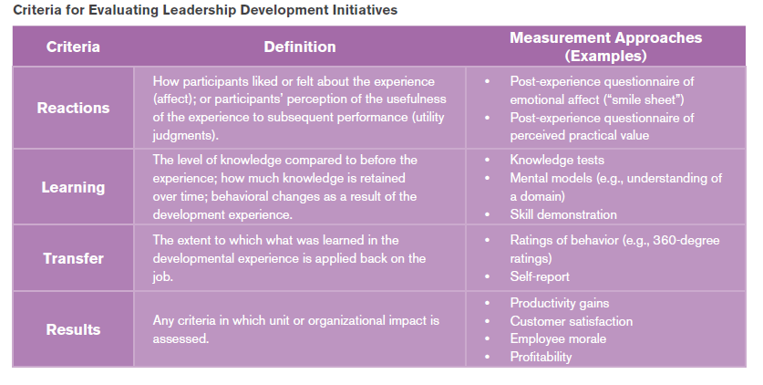

**ACS Model of Leadership Development**

One approach to this issue is the ACS model proposed by researchers at the Centre for Creative Leadership. The philosophy underlying this model is that any experience can be made more developmental to the extent that it incorporates or enhances aspects of assessment, challenge and support (ACS).

1. ***Assessment***refers to a diagnosis of the current state of the individual or organization in terms of leadership capacity. These data help to clarify what needs to be learned, improved or changed. The data can come from oneself (e.g., self-reflection, scores on personality inventories) or from others (e.g., feedback, customer evaluations). Good assessment data also provides the motivation to close the gap between the current and an ideal future state.If no gap exists, this assessment data can still be helpful in terms of enhancing self- confidence.
2. ***Challenge***occurs when current capabilities are tested. More challenging experiences are those that require some stretch out of comfortable and habitual ways of thinking and acting. It involves some willingness for risk-taking and feeling a little (or a lot) uncomfortable. It is through taking on a developmental challenge that the limits of how things are normally done become apparent. Challenges are motivating in terms of the desire to master a new skill orway of thinking. Challenges also offer the opportunity for experimentation and exposure to new perspectives.
3. ***Support*** in the form of positive reinforcement from co-workers, bosses and the broader environment helps to build self-confidence and master the challenge at hand. Developmental challenges are often difficult physically, psychologically and emotionally.Without substantial support, itis hard to bring about lastingchanges at an individual, group or organizational level. As noted in several places in this report, sending a changedperson into an unsupportive interpersonal environment is one way that organizations waste their resource investments in development.

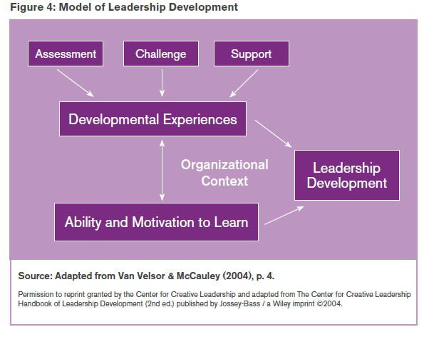

The most powerful developmental experiences are ones that include a variety of assessment, challenge and support mechanisms. The developmental process is also one that shapes and is shaped by the *ability and motivation to learn*. Developmental experiences are thought to enhance both of these aspects of learning, but these components of learning also influence the quality of the developmental experience.

*As an example*, someone with little ability or motivation to learn will get comparatively less from a developmental experience than someone who is able (developmentally ready) and motivated. But rich experiences will also enhance learning ability and motivation. The relationships between developmental experiences, the ability and motivation to learn, and leadership development all take place in an *organizational context*. Aspects of the organization’s context, such as its size, mission, strategy and culture, influence the leadership development process. This influence extends to the overarching focus, the degree of integration with other processes, how systemic it is and ultimately who is responsible for the system.

**Identifying High Potential employees : A white paper by John Azzara**

IN his paper, author John Azzara has described a wide range of assessment procedures organizations employ to identify high potential talent. These assessment procedures are listed in order of increasing level of sophistication:

1. ***The Buddy Approach.*** This approach is characterized by people with decision-making authority identifying their “buddies” as high potential. Comments used by decision makers that characterize this approach are, “John is a good guy, we should plan on promoting him” or “I like John, let’s give him the job when it’s available.”
2. ***The Tenure Approach.*** This approach is characterized by promoting or identifying employees that have been with the company the longest. The general theory is that the person has paid his or her dues and therefore should be moved into a critical role. Another rationalization for this approach is that the employee, because of his/her longevity with the company, must have acquired the appropriate knowledge, skill and ability to be successful in a more critical role.
3. ***The Manager Appraisal Approach*.** This approach is characterized by having a manager identify a subordinate for promotion or special development based on the manager’s independent judgment of what high potential means. In this approach, managers are usually left to their own devices to develop criteria from which they base their decisions.
4. ***The Decision-Makers Consensus Approach.*** This approach is characterized by decision-makers meeting as a group to discuss employee suitability for promotion or special development. Although better than the previous approaches, there is usually little in the way of criteria to help articulate what is meant by potential. This can result in un-productive or inaccurate decisions.
5. ***The Criteria Based Approach.*** This approach is characterized by having criteria that articulate how a high potential employee behaves. Decision-makers are required to use these criteria to identify talent and to justify their choices. Typically, assessment tools are used to help measure the criteria. Examples of such tools are multi-rater feedback (360-degree) and assessment centres.

# Models

**SHL Leadership Model**

The SHL Leadership Model covers four leadership functions critical to leadership effectiveness in any organisation. Each of these four leadership functions can be considered in terms of a management focus and a leadership focus.

* **Management (transactional focus)** is focused on keeping the system running effectively and delivering dependable performance of specified objectives.
* **Leadership (transformational focus)** is focused on creating, developing or changing the system’s direction and inspiring both people and the organisation to achieve beyond expectations

Each leadership function is associated with two competencies, based on the SHL Great Eight Competency Factors. One competency is more relevant to a management focus and one to a leadership focus.

**Competencies**

|  |  |  |  |
| --- | --- | --- | --- |
| Leadership Function | Definition | Management Focus  (Transactional) | Leadership Focus  (Transformational) |
| Developing the vision | This involves the critical analysis of the current situation, and the generation of ideas to move forward (Strategy). | **Analysing &**  **Interpreting** | **Creating &**  **Conceptualising** |
| Sharing the goals | This involves persuasively communicating the vision to others, as well as personally adapting to the changes that the new strategy brings (Communication). | **Adapting & Coping** | **Interacting &**  **Presenting** |
| Gaining support | This involves gaining other people’s support by motivating and empowering them to implement the actions needed to deliver the strategy (People). | **Supporting &**  **Co-operating** | **Leading & Deciding** |
| Delivering success | This involves using operational efficiency and commercial acumen to effectively implement the strategy (Operations). | **Organising &**  **Executing** | **Enterprising &**  **Performing** |

**Preferred Style: Balanced Mix of Styles**

Individuals who capture elements of both the transactional management and transformational leadership styles are likely to adapt their approach to meet the needs of differing challenges and contexts, maintaining effectiveness, whilst being open to new innovations.

|  |  |
| --- | --- |
| Individuals with a balanced mix of styles are at their best:   * When responsible for ensuring operational effectiveness. * In roles which bring together technical and creative aspects. * In situations where they can support others through change. * Balancing day to day management with a broader, more strategic focus. | Individuals with a balanced mix of styles may find challenging:   * Very competitive organisations with high performance expectations. * Roles that require a highly strategic orientation. * Organisations that maintain the status quo even when not effective. * Very fast paced industries. |

Definitions for overall leadership style (leadership versus management) and the four leadership functions are presented here. For each function, the definitions of the four core styles related to that function are given.

|  |  |
| --- | --- |
| Overall: Management Focus vs. Leadership Focus | |
| Leader  Leaders transform organisations through innovation, drive, persuasive communication and entrepreneurial flair. However, their efforts may be less effective if they overlook transactional aspects associated with effective management. | **Corporate Leader**  Corporate Leaders transform organisations by combining innovation, drive, persuasive communication and entrepreneurial flair with the effective execution of analysis, personal resilience, interpersonal sensitivity and structured implementation. |
| Contributor  Contributors take pride in focusing on tasks within a defined area and using tried and tested approaches to resolve problems. They are likely to feel comfortable taking direction from others and may feel uneasy at the prospect of managing other people, preferring to focus on their own specific area of responsibility. | **Manager**  Individuals who combine technical expertise with a clear transactional management style are likely to be effective in coping with pressure and driving operational success in the here-and-now. However, future success also depends on a steady flow of innovation that leads to new business propositions in response to evolving markets. |

|  |  |
| --- | --- |
| Developing the Vision | |
| Creator  Creators work well in situations requiring openness to new ideas and experiences. They typically handle situations and challenges with innovation and creativity and will often support or drive organisational change. However, their enthusiasm for change may overlook positive aspects of the status quo. Given that their style is also less focussed on quantitative analysis they may also overlook the need to check the feasibility of their ideas. | **Visionary**  Visionaries excel in developing a vision for the organisation while critically evaluating the facts, and creating the ideas and concepts that move the organisation forward. However, in certain contexts they may be inclined to over analyse a situation and to overlook positive aspects of the status quo. |
| Conservator  Conservators thrive in environments where they can continue to use well-proven methods and discourage incompatible ideas. They are less inclined towards quantitative analysis, and typically apply established methods and ways of working to resolve practical problems and maintain the status quo. | **Analyst**  Analysts are naturally suited to critical thinking and quickly get to the heart of complex problems and issues. They work most effectively in situations requiring the application of established methods and may struggle to create new ideas. Analysts will strive to apply tried and tested approaches to the resolution of problems and if left unguided may be inclined to over analyse a situation. |

|  |  |
| --- | --- |
| Sharing the Goals | |
| Communicator  Communicators relate to others in a confident manner, presenting a convincing case for the new vision and strategy. They enjoy public speaking, network effectively and are generally successful in persuading and influencing others. However, they can find it difficult to cope effectively with the personal pressures often associated with organisational change. | **Change Ambassador**  Change Ambassadors inspire others to share the organisation’s new vision and goals. They relate to others in a confident and relaxed manner, enjoy public speaking and network effectively. Change Ambassadors flourish on pressure and change, projecting confidence and providing re-assurance to others. However, they may underestimate the personal challenges experienced by others in adapting to change. |
| Stability Seeker  Stability Seekers thrive in stable environments and those where networking is less important. They are likely to be socially reserved and dislike public speaking, choosing other ways of communicating. They may find the personal pressures associated with organisational change challenging, but their focus on more negative aspects of a situation could help highlight potential issues. They tend to behave consistently and not to pressure others, which can provide a counter balance to more forceful approaches. | **Adjuster**  Adjusters focus on the positive aspects of the new vision and strategy, and respond well to the challenges it brings. However, being private and socially reserved, they may not effectively share their positive outlook, and miss opportunities to persuade and influence others. They prefer not to be in the centre of attention and may dislike public speaking. |

|  |  |
| --- | --- |
| Gaining Support | |
| Decision Maker  Decision Makers naturally seek to take control, initiate action and exercise leadership. They prefer not to engage with the personal concerns of others, which may make it easier for them to make hard choices impacting other people. As they are more strongly focussed on task-related than people- related aspects of the job, they may underestimate others’ concerns about new goals. This may limit the extent to which they gain other people’s support. | **People Leader**  People leaders listen to other people’s views, and are astute at judging how best to motivate and empower others. They naturally prefer to take control, initiate action and exercise leadership. Their people-focused approach, combined with their natural tendency to take responsibility, helps them to gain other people’s trust. However, they may find it difficult to make tough decisions which may have a negative impact on others. |
| Individualist  Individualists are more strongly focussed on task-related than on people-related aspects of the job. They prefer not to engage with the personal concerns of others and tend not to act in a directive manner. They are open in expressing their own opinions and may seek to take an independent advisory role within the group. | **Team Player**  Team Players naturally put people issues first, supporting colleagues and showing respect towards others. They understand how to motivate other people and gain their support. However, they are happy for others to take the lead and this may limit the extent to which they actively direct the efforts of others. |

|  |  |
| --- | --- |
| Delivering Success | |
| Entrepreneur  Entrepreneurs are most effective in bringing a competitive edge to their work. They prefer to address issues flexibly and may find it uncomfortable and constraining to adopt a procedural or process orientation. Their competitive drive may support a strong interest in business, commerce and finance. They are inclined to focus on the pursuit of personal work goals and objectives, but may not always plan in detail how they will achieve these. | **Business Driver**  Business Drivers focus on results, achievement of personal work goals and objectives and career advancement. This may also mean that they show a strong interest in business, commerce and finance. They identify and act upon new opportunities by working energetically in a systematic and organised manner. While they may sometimes become preoccupied with detail, they are generally respected for running the organisation smoothly and efficiently. |
| Idealist  Idealists prefer to address issues flexibly. They derive satisfaction by applying steady effort to the task at hand and may find it uncomfortable and constraining to adopt a more structured approach. They are less driven by competition, or by the need for personal recognition. This means that they may fail to recognise or capitalise on potential commercial opportunities. However, their steady pace and flexible style provides a counter balance to more intense approaches. | **Implementer**  Implementers specialise in getting things done and derive satisfaction from having many tasks to do. They like to follow processes and procedures, working in a systematic and organised manner. Implementers focus on the delivery of a defined product or service to predetermined standards and can find it challenging to accommodate deviations from the plan. Given that they are less driven by competition and the need for personal achievement, they can fail to recognise or capitalise on potential commercial opportunities. |

**Hogan and Kaizer model of Leaders And Organizational Effectiveness**

Hogan and Kaiser (2005) propose a model for integrating the literatures on personality, leadership, and organizational effectiveness. They suggest that personality predicts leadership style, leadership style impacts employee attitudes and team functioning, and these variables then predict organizational effectiveness. The figure below illustrates these relationships and also incorporates the moderating role of discretion and the distinction between leadership in organizations and leadership of organizations.

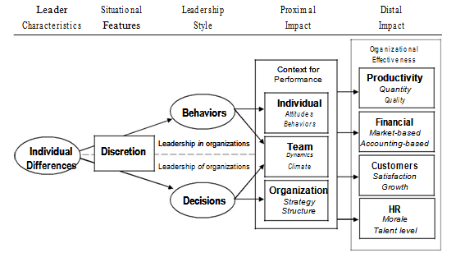

Leadership involves persuading individuals to give up their purely selfish interests for a while and contribute to the overall performance of the organization. Thus, leadership involves building and motivating a team to outperform the competition. In an organizational context, it is important to distinguish between two types of leadership influences. The first is the influence that leaders exert in direct social interaction; this is leadership as face-to-face social influence, leadership in an organization. The second is the indirect influence that leaders exert through their decisions about direction, organizational structure, and objectives. This is leadership of an organization, guiding collective action impersonally by setting goals, defining roles and staffing positions, allocating resources, and establishing policies. Although direct influence is an important activity for all leaders in an organization, indirect influence is a key activity for strategic senior leadership.

***Leader Characteristics:*** Discretion moderates the effect of leader attributes. Although this applies to individual differences in cognitive ability, knowledge, skills, and experience, it is believed that personality is the most potent source of individual differences in leadership. There are three reasons for this. First, meta-analyses show that, when organized in terms of an adequate taxonomy (e.g., the Big Five), the validity for personality is greater than the validity of cognitive ability for predicting leadership. Second, personality is a broader domain than cognitive ability; there is, in principle, more variance to personality. And third, other scholars also argue that personality is the primary source of differences among leaders.

***Leadership Style:*** The more discretion leaders have, the more their leadership style will reflect their personalities. Leadership style can be characterized in terms of interpersonal behaviour and preferred patterns of decision making. The psychological study of leadership focuses on behaviour—being considerate, showing initiative, transforming followers, and other direct methods of interpersonal influence, whereas the managerial literature emphasizes decision making with regard to strategy, structure, staffing, and policy—all of which influence a workforce in indirect and impersonal ways.

***Impact of Leadership:*** Leadership style affects organizational performance directly and indirectly through its impact on the organizational unit. Put simply, leaders get things done through other people. Influencing people, teams, and organizational features is the proximal effect of leadership; the proximal effects create business results as a distal impact.

*Proximal Impact: Organizational Process*

Leader behaviours directly influence the attitudes (e.g., commitment, satisfaction) and behaviours (e.g., performance) of individual employees. Leader behaviours also directly affect team dynamics and climate — for instance, by facilitating communication and coordination, resolving intra group conflict, and rewarding or sanctioning certain behaviours. Leader decisions also indirectly influence teams by establishing goals, by assigning people to roles, and by distributing resources. And leader decisions impact organizations by defining strategic direction, organizational structure, and formal policy.

Thus, the mechanisms through which leadership style affects organizational performance operate at the individual, team, and organizational level of analysis. A leader's impact across these three levels can be seen as creating a context for performance, because the leader's role is to facilitate team performance. On the one hand, this promotes an internal focus—with an emphasis on activities within the group. On the other hand, because contexts are more or less conducive to performance, these actions affect a team's performance in competition with rivals, and that translates directly into organizational effectiveness.

*Distal Impact: Organizational Effectiveness*

Although psychologists have tended to ignore the topic of organizational effectiveness, it is the ultimate measure of leader effectiveness. There are four general classes of variables that constitute a "balanced scorecard" (Kaplan & Norton, 1996) and that apply to a wide range of business organizations: Productivity, finances, customer service, and human resources.

**Productivitymeasures** reflect relative efficiency in transforming inputs (capital, people, materials) into outputs (goods and services). This is the standard social psychology measure of organizational effectiveness (Katz & Kahn, 1978) and includes such indices as quantity and quality, sales per employee, and rate of innovation. There are two distinct kinds of **financial measures**, market-based and accounting-based. Market-based metrics (e.g., total shareholder return, price-to-earnings ratio) reflect profitability and value to shareholders whereas accounting-based measures (e.g., return on equity, assets, or sales; economic value added) are more internally focused and are easier to manipulate (Anderson & Tirrell, 2004). **Customer serviceindices** concern customer satisfaction, retention, and growth. Finally, **human resource-based measures** reflect how well an organization manages talent. Metrics in this group include rate of turnover and morale. Bench strength—the number and quality of future leaders—belongs here as well. An important point about customer service and human resource-based measures is that, although they are not reflected directly in the "bottom line," they are crucial to the sustainability of productivity and financial performance. That is, when production goals and financial results are achieved while alienating customers and demoralizing employees, the organization will inevitably suffer.

Taken together, these measures of business results map the domain of organizational effectiveness, the distal impact of leadership.

# Designing a Succession Planning Program

# CPS- Human Resource strategies give a seven step model for succession planning:

1. Obtain leadership support.
2. Assemble a Succession Planning Team
3. Identify the agency’s leadership gaps.
4. Assess the readiness of current staff to assume those leadership positions.
5. Identify high-potential employees.
6. Diagnose their strengths and developmental needs.
7. Select and implement strategies for accelerating the development of these employees.

# Assessment Techniques for Promotion

**9 Box grid**

A “nine-box grid” is a matrix tool that is used to evaluate and plot a company’s talent pool, based on two factors, which most commonly are performance and potential.  Typically on the horizontal axis is "performance" - measured by performance reviews.  On the vertical axis is typically "potential" - referring to an individual's potential to grow one or more levels in a managerial or professional capacity.

Nine-box grids are actively used during the talent review process.  During this process a group of managers works together to place individuals on the X-Y axis to help identify who are the highest potential individuals, who needs development, and who needs coaching on performance improvement.  It is also a very valuable tool to help calibrate compensation decisions.

Each of the nine boxes has a different set of actions associated with it.  People who are very high-performers in their current role, but not "high-potential" yet, are possibly experts in their functional area who may or may not want to move into leadership.  Our research and assessments have many examples of these tools and how to manage the talent review process.

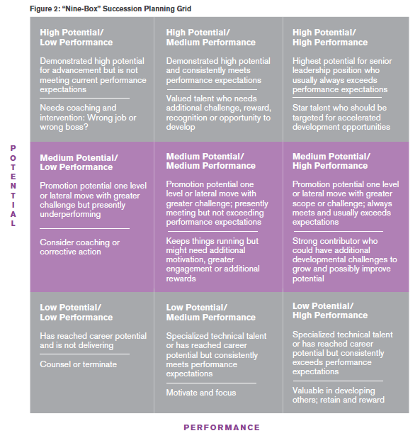

This section outlines the succession management process at Dow Chemical using the 9 box grid.

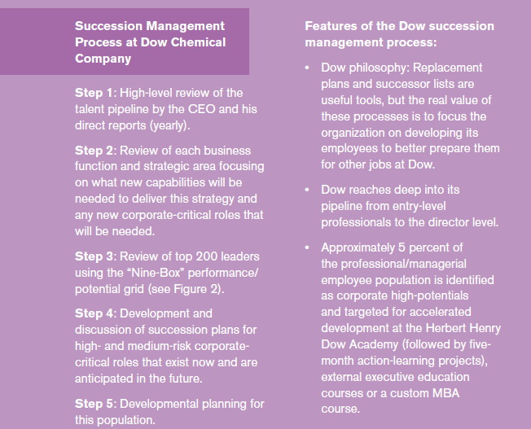

## Thomas Profiling

## *Thomas Profiling*

## Thomas International provides people assessments which empower business leaders to transform the performance of their teams and individuals – and deliver an immediate impact on their organisation.

It helps organization recruit, retain, develop and manage their people. It gives insight into staff – what motivates them, their core strengths and limitations, and their potential. And it adds a high level of certainty to all people-related decisions.

***Thomas PPA***

65% of businesses say they need to focus on leadership skills and 55% on front-line people management skills in order to meet their objectives in two years’ time.  
With leadership and people management skills so high on the agenda, how do organizations make sure that their managers are spending the right amount of effort with the right people, and that they’re working on the issues that will bring the biggest benefit to business?  
Thomas Personal Profile Analysis (PPA) helps fast-track managers by providing a rapid understanding of the strengths and limitations of their people. It will pinpoint the areas that their people need to develop and it will boost your managers’ ability to motivate and communicate on an individual and team level.  
  
Thomas PPA provides an initial **PPA profile**and will answer your many questions, including:

* What are this person’s strengths and limitations?
* How do I motivate this person?
* What’s the best way of communicating with this person to get the best out of them?
* Is this person showing frustrations in their role?
* Is our business playing to this employee’s strengths?

Sample Report:

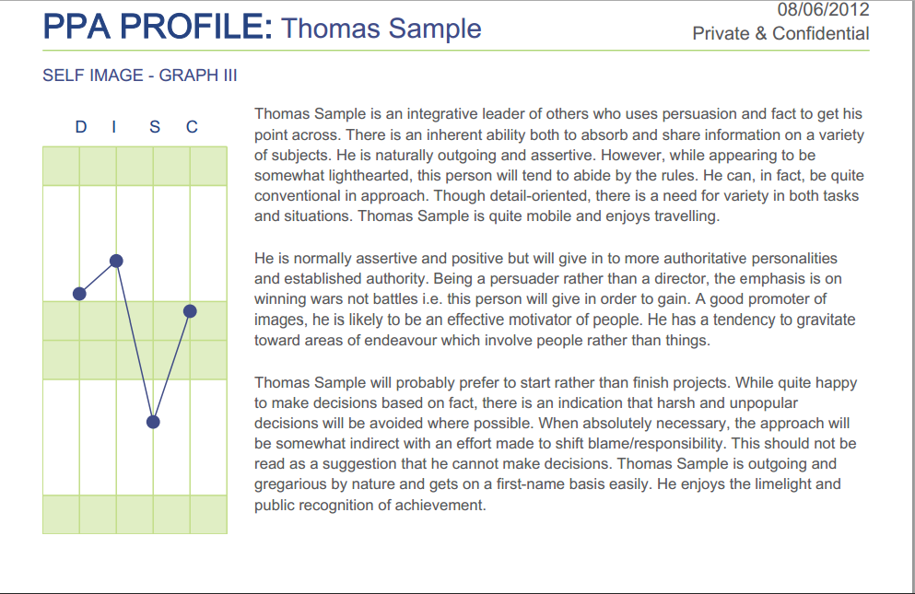

***Thomas JOB***

This is another assessment tool which helps organizations identify the behavioural requirements of any job. Used in conjunction with **PPA**, Thomas Job enables organizations to match the ideal behaviours for the job with the behavioural profile of candidates and employees, using a ‘goodness of fit’ scale.

Thomas Job can be used to achieve a greater level of certainty for:

* recruiting or selecting the right person for the right job
* identifying mismatched employees and redeploying them in more suitable roles
* boosting morale and loyalty
* managing underperformance
* getting the best out of your talent

Sample Reports:

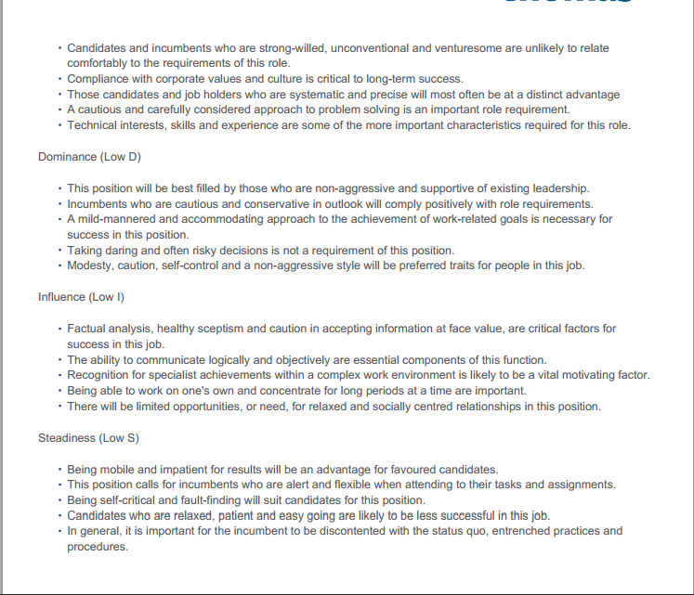

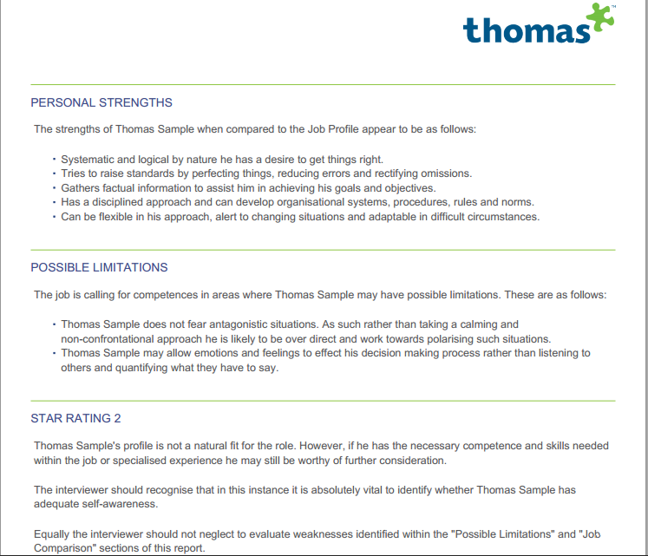

## Competency Based Assessment

Competencies are the behaviours that individuals exhibit that depict the presence of a competence in them. Following are the definitions of Competencies given by renowned authors and organizations.

**United Nations Industrial Development Organisation (2002)**

“A competency is a set of skills, related knowledge and attributes that allow an individual to successfully perform a task or an activity within a specific function or job.”

**RANKIN (2002)**

“Competencies are definition of skills and behaviours that organizations expect their staff to practice in work.”

**BOYATZIS (1982)**

“Competencies are underlying characteristics of a person that results in effective a superior performance.”

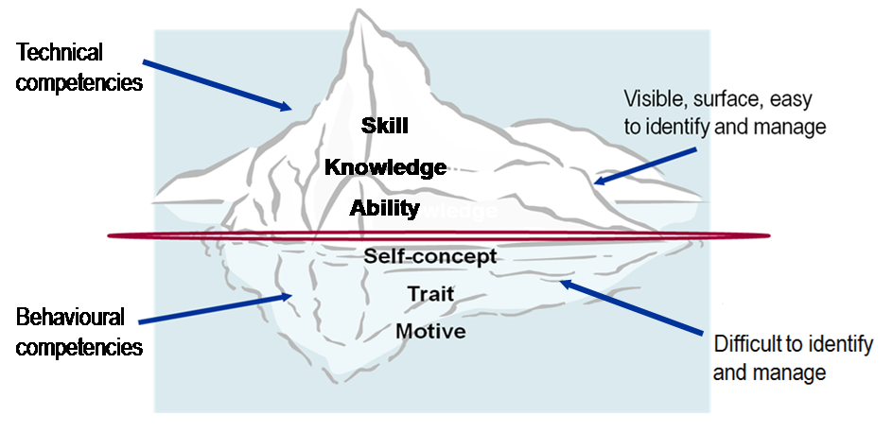

Competency may take the following forms:

* Knowledge
* Attitude
* Skill

Other characteristics of an individual including

* Motives—These are the things a person consistently thinks about or wants and that causes a person to act in a certain manner
* Traits—Traits are physical characteristics that define your personality, your responses to situations
* Self-concept—A person’s view of himself and his attitudes and values
* Knowledge—What information a person has about a specific area
* Skill—It is the ability to perform well a certain physical or mental task

“Katz in a classic article published in Harvard business review in 1994, grouped competencies into 3 categories which were later extended to four including

1. *Technical i.e. relating to technology/ know-how-* It is associated with function, role or task and hence, termed as functional category.
2. *Managerial/ Organizational-* It deals with managerial aspects including planning, resource mobilizing, organizing, monitoring etc.
3. *Human/ Behavioural-* These competencies deals with personal, inter personal and group matters.

4. *Conceptual-* They include visualization, model building and so on.

He called the peculiar character of an organization its distinctive competence. The art of good management is the ability to make a practical assessment of an organization’s suitability to its task or strategy.”

Competency Mapping is the process of identifying certain behaviours and skills which distinguish excellent and outstanding performance from the average.

Organizations need Competency Mapping in following areas.

Training and Development

Recruitment and Selection

Career

Planning

Performance Appraisal

Succession Planning

Compensation

Replacement Planning

Competency Mapping

A competency interview (also referred to as a situational, behavioural or competency based interview) is a style of interviewing often used to evaluate a candidate's competence, particularly when it is hard to select on the basis of technical merit: for example, for a particular graduate scheme or graduate job where relevant experience is less important or not required. However, increasingly, companies are using competency based interviews as part of the selection process for experienced recruitment and for taking promotion decisions, as it can give valuable insights into an individual's preferred style of working and help predict behaviours in future situations.

Competency based interviews help identify if the candidate in question has the right set of competencies required for a role. For this purpose organizations have to first conduct a competency mapping exercise. This helps organizations identify specific competencies required for each role.

Competency based interviews focus on the behavioural aspects and are combined with Behavioural Event Interviews to seek out examples from candidates past experiences. It is based on the premise that past performance is an indicator of future performance.

Despite the extensive use of the interview as a selection tool, evidence suggests that it can be a poor predictor of future job performance. Here are a number of steps that can be taken to improve its effectiveness:

***1. The Interview Should Be Properly Structured***

Adhering to a set structure is probably the single most important technique to improve the reliability of the selection process. Structure helps focus the discussion and ensures that candidates are assessed against the same criteria. It also enables us to gather information that is based on actual evidence rather than on assumptions based on stereotypes; with such an approach, the assessment of each candidate’s potential strengths and weaknesses starts on equal footing. In addition, having a structure makes it easier for the interviewer to monitor the progress of the interview, thereby ensuring that the discussions remain job-related. Moreover, adherence to a framework exposes possible gaps in the information collected.

***2. Focus on Obtaining Evidence of the Candidate’s Past Behaviour***

Decisions must be made based on evidence, rather than on the opinions of the interviewer. The latter should avoid basing selection decisions on unsubstantiated opinions, speculation, or stereotypes. The most effective interviewing style is one that explores the candidate’s past behaviour. Past behaviour is one of the best predictors of future behaviour and the core of competency based interviewing.

***3. Interviews Should Be Supported By Other Assessment Techniques***

It is recommended that information collected from the interviewee be supplemented with other assessment techniques such as ability tests or assessment centres, which can provide objective and reliable evidence about the suitability of the candidate for the job. The use of multiple assessment techniques can improve the validity of selection procedures because it enables a candidate’s skills to be evaluated across a range of different situations (e.g. role plays or group interactions etc). This facilitates the identification of areas of consensus and dissentience, thus providing an evaluation of a candidate’s suitability from various viewpoints.

***4. More Than One Interviewer Involved In the Selection Process***

Ideally more than one interviewer should be involved in the selection process, especially if no other techniques of assessment are used. Since different interviewers will not possess the same biases and prejudices, a discussion with all the interviewers should take place after the interview.

## Maturity (Readiness) Matrix

## A number of organizations also use maturity matrix for taking promotion decisions. Readiness is the level of motivation and capability to accomplish the given task. Readiness of employee depends on many internal and external factors. In order to understand the meaning of term Readiness, it is necessary to define terms Capability and Motivation.

## *Capability* describes:

* Previous experience on the same or similar task
* Special training for given task
* Understanding of the task
* Understanding of employee’s role toward the task

***Motivation*** is related to:

* Level of confidence related to task accomplishment
* Level of responsibility related to given task
* Wish of employee to accomplish the task
* Incentive for the task accomplishment

**Since readiness of different levels of factors of Capability and Motivation, it can be described by four different categories:**

1. R1 – Low Capability and Low Motivation. This is usually for new employee who does not have capabilities for a new position. Also, the level of motivation may be low, due to lack of knowledge.
2. R2 – Low Capability and High Motivation. This is typical for employee who wants to make progress on his position, but is missing some capabilities.
3. R3 – High Capability and Low Motivation. Experienced employees are sometimes lacking the morale (tiredness, too long time at the same position, ... ).
4. R4 – High Capability and High Motivation. This is example of fuly developed employees who have both the capability and motivation.

## Cognitive Ability Tests

## Cognitive ability is a generic term describing the process and results of information processing (perception, conceptualization, problem solving, etc.); the term is frequently used in psychological assessment as a synonym for 'intelligence'. The cognitive ability questions used in psychometric tests can take a variety of forms depending on the type of reasoning ability that the employer thinks is important. Most psychometric tests are made up of questions that can be categorized as either: numerical, verbal, abstract, spatial or mechanical in nature. Some general psychometric tests contain questions of different types in the same test whereas others may be specific. For example a verbal reasoning ability test will only contain questions designed to measure your ability to understand and interpret information presented in words.

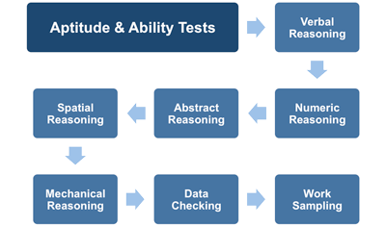

Cognitive ability tests typically use questions or problems to measure ability to learn quickly, logic, reasoning, reading comprehension and other enduring mental abilities that are fundamental to success in many different jobs.  Cognitive ability tests assess a person’s aptitude or potential to solve job-related problems by providing information about their mental abilities such as verbal or mathematical reasoning and perceptual abilities like speed in recognizing letters of the alphabet.

**Advantages**

* Have been demonstrated to produce valid inferences for a number of organizational outcomes (e.g., performance, success in training).
* Have been demonstrated to predict job performance particularly for more complex jobs.
* Can be administered via paper and pencil or computerized methods easily to large numbers.
* Can be cost effective to administer.
* Does not typically require skilled administrators.
* Can reduce business costs by identifying individuals for hiring, promotion or training,who possess the needed skills and abilities.
* Will not be influenced by test taker attempts to impression manage or fake responses

**Disadvantages**

* Are typically more likely to differ in results by gender and race than other types of tests.
* Can be time-consuming to develop if not purchased off-the-shelf.

A typical cognitive assessment will measure the following aspects:

***Motor Skills***

The use of motor skills tests in a cognitive assessment is probably the largest difference between it and an IQ test. Many people do not realize that motor function is, in fact, a cognitive function. Many times, difficulty with fine motor skills can indicate that the test taker has a potential cognitive impairment.

***Attention***

Many cognitive assessments will use a scale to measure the attention scale of the person being assessed, that is to say, the subject’s ability to focus on internal or external stimuli, and the length of the individual’s focus, or attention span. Often, a series of letters or patterns will be used, and the test taker will be asked to replicate the pattern when it is no longer visible. Though subtle, this is a departure from a memory test, though the two are sometimes intertwined.

***Perception***

Perceptive tests measure a subject’s ability to identify or recognize external stimuli using their senses of sight, hearing, touch, and sometimes smell. Common tests include the use of optical illusions like the Rubin Vase, which is a visual object that looks like a vase from one perceptive angle, while the negative space reveals two faces looking at one another.

***Executive Skills***

Much of our cognitive function falls under the umbrella of “executive skills”, which include an individual’s ability to self-regulate, ignore or act upon inhibitions, etc. Probably the most easily recognizable executive skill is the ability to make decisions, either after lengthy consideration or on the fly. A cognitive assessment will measure the subject’s initial ability to make decisions, but remember that you can further develop cognitive function over time. It is for this reason that you can [practice certain exercises and to master decision making abilities.](http://www.udemy.com/cognitive/?tc=blog.cognitiveassessment&utm_source=blog&utm_medium=udemyads&utm_content=post84916&utm_campaign=content-marketing-blog&xref=blog)

## Personality Tests

## The emergence of the five-factor model (FFM) allowed personnel psychologists to develop more construct valid instruments with better predictive validity. The FFM was able to bring order to the field and demonstrate that such characteristics are relatively enduring and stable.

Over time practitioners have noted the value in combining personality and behavioural assessments for executive development. Combining both types of assessments is increasingly recognized as being a more robust process than using either method alone because it allows for the examination of convergence as well as possible divergence of the data. By integrating the patternof results across measures the feedback facilitator, coach or consultant working with the data can generate deeper insights. This in turn yields enhanced interpretation and more targeted one-on-one feedback and developmentplanning. As a result, the practice of using these types of measures together has become commontoday in the leadership and OD field.

Personality measures can be in the form of interviews, in-basket exercises, observer ratings, or self-report inventories (i.e., questionnaires). Some commonly measured personality traits in work settings are extraversion, conscientiousness, openness to new experiences, optimism, agreeableness, service orientation, stress tolerance, emotional stability, and initiative or being proactive.  Personality tests typically measure traits related to behaviour at work, interpersonal interactions, and satisfaction with different aspects of work.  Personality tests are often used to assess whether individuals have the potential to be successful in jobs where performance requires a great deal of interpersonal interaction or work in team settings.

There are many different types of personality tests. The most common type is the self-report inventory, also commonly referred to as objective personality tests. Self-report inventory tests involve the administration of many questions/items to test-takers who respond by rating the degree to which each item reflects their behaviour and can be scored objectively. The term 'item' is used because many test questions are not actually questions; they are typically statements on questionnaires that allow respondents to indicate level of agreement (using a Likert scale or, more accurately, a Likert-type scale).

The most widely used objective test of personality is the Minnesota Multiphasic Personality Inventory (MMPI) that was originally designed to distinguish individuals with different psychological problems. In addition to self-report inventories, there are many other methods for assessing personality, including observational measures, peer-report studies, and projective tests.

**Advantages**

* Have been demonstrated to produce valid inferences for a number of organizational outcomes.
* Can reduce business costs by identifying individuals for hiring, promotion or training who possess the needed skills and abilities.
* Are typically less likely to differ in results by gender and race than other types of tests.
* Can be administered via paper and pencil or computerized methods easily to large numbers
* Can be cost effective to administer
* Does not require skilled administrators.

**Disadvantages**

* May contain questions that do not appear job related or seem intrusive if not well developed
* May lead to individuals responding in a way to create a positive decision outcome rather than how they really are (i.e., they may try to positively manage their impression or even fake their response)
* May be problematic for use in employee selection if the test is one used to diagnose medical conditions (i.e., mental disorders) rather than simply to assess work-related personality traits

## Assessment Centres and Simulations

Assessment centre employs multiple assessment methods and exercises to evaluate a wide range of competencies used to make a variety of employment decisions (e.g., employee selection, career development, promotion). Assessment centres can be used to assess small groups of people at relatively the same time. Many assessment centre exercises resemble work sample tests designed to simulate the actual challenges found on the job.

Assessment centre exercises can be used to measure many different types of job related competencies, including interpersonal skills, oral and written communication, planning and evaluating, and reasoning and problem solving abilities. A frequently used assessment centre exercise is the in-basket test. A typical in-basket test is designed to simulate administrative tasks. During this exercise, applicants are asked to play the role of a person new to the job and are instructed to read and react to a pile of memos, messages, reports, and articles.

Some assessment centre exercises can be used to evaluate groups and individual behaviours in group situations. For example, in a leaderless group discussion, a group of applicants is tasked with solving a problem or a series of problems in a limited amount of time. Other assessment centre exercises include, but are not limited to, job knowledge tests, personality tests, and structured interviews. Applicant performance is usually observed and evaluated by multiple assessors (i.e., raters). When used for internal promotion purposes, assessment centres are frequently designed to reflect values and practices specific to an organization, but when used to assess external applicants, assessment centres should be designed to focus on the job and level of the job (e.g., manager) rather than practices unique to the organization. While assessment centres can be designed for various types of jobs, they are particularly effective for assessing higher-level managerial and leadership competencies. Assessment centres require extensive experience to develop, considerable logistical planning to set up, and numerous personnel to administer. Highly trained assessors are needed to observe and evaluate applicant performance on the group and individual exercises.

**Advantages**

* Have been demonstrated to produce valid inferences for a number of organizational outcomes (e.g., promotion rates).
* Can reduce business costs by identifying individuals for hiring, promotion or training who possess the needed skills and abilities.
* May be viewed positively by test takers who see the close relationship between the test and the job.
* Can provide useful feedback to test takers regarding needed training and development.
* Focus more heavily on behaviour demonstration than simply assessing characteristics.
* Are typically less likely to differ in results by gender and race than other types of tests.

**Disadvantages**

* Can be costly to create and administer.
* Require more labour (e.g., assessors, role-players, etc.) to administer than most other methods.
* Require more time to administer than most other methods.
* Can be difficult to keep calibrated or standardized across time and locations

## CLC Model of Employee Potential

A “high-potential employee” is an employee who has been identified as having the potential, ability, and aspiration for successive leadership positions within the company. Often, these employees are provided with focused development as part of a succession plan and are referred to as “HiPos.” Their work performance have been consistently high and is likely to continue being high even with increase in the work level or job responsibilities.

High-potential employees are scarce in most organizations and misidentifying them can have costly repercussions. A Corporate Leadership Council (CLC) talent management survey shows that a deep, potential-rich organization’s average employee currently performs 22 percent better than the average employee at an organization that does not focus on employee potential (CLC, 2005a). This can translate into a substantial advantage for a company over its competitors. Building a culture of development is essential to fully leverage talent management in an organization. In global companies with strong, respected cultures, motivation and a sense of belonging are nurtured so that employees are not motivated primarily by financial reward, which can be easily emulated by another organization resulting in easy attraction and retention of employees. The identification of talent in the HIPO program is typically conducted by management within an operating group or business unit to collect data on the employees who are high performers.

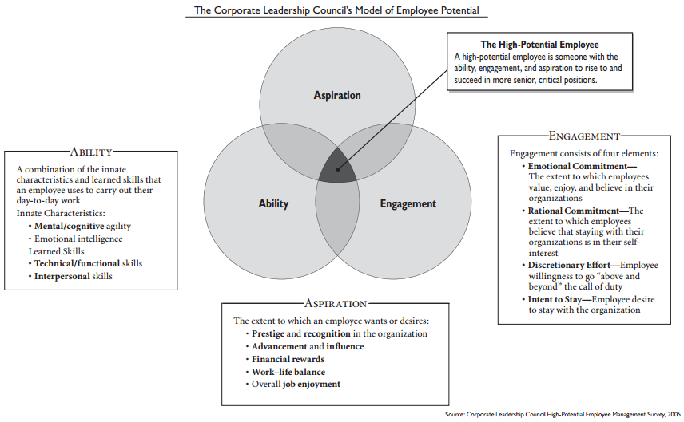

To rise to and succeed in more senior, more critical positions, employees must have the aspiration, engagement and ability to do so. Ability is most important, engagement second and aspiration third, but none alone can serve as a guarantee. Without significant amounts of all three, employees will simply fail to excel in the next more critical job.

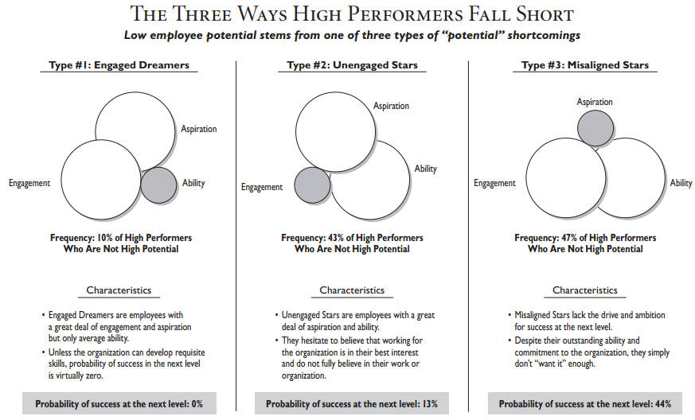

## Management Readiness Profile (MRP)

The Management Readiness Profile (MRP) is an assessment tool that identifies the readiness of candidates for management responsibilities. The Management Readiness Profile (MRP) assessment helps measure the attitudes and aptitudes that are commonly critical to management success. An applicant who possesses these attitudes and aptitudes will generally be ready for a management position.

The Management Readiness Profile will help you make accurate selection, placement and promotion decisions involving entry-level supervisors. A better fit between managers and their leadership responsibilities means more effective work teams, higher morale, lower turnover among top performers and maximum profitability. In addition, the MRP contains a Validity-Candidness scale that measures the extent of socially desirable responses. Lower scores indicate a tendency to exaggerate positive qualities and minimize negative traits.

The MRP is easy to administer to groups or individuals. Candidates usually complete the instrument in less than one hour, the results are normally sent to you within hours and it is an inexpensive and highly reliable way to assess applicants.

***Scales and Measures***

* Business Ethics
* Management Interest
* Leadership
* Energy Level
* Practical Thinking
* Management Responsibility
* Interpersonal Skills
* Validity/Candidness

***The Assessment Report***

One comprehensive score, the Management Readiness Index, combines the results of the individual scales to reflect a person's overall managerial readiness. In addition, separate scores for each of the MRP scales identify an individual's strengths and weaknesses in each specific area.

The Management Readiness Profile (MRP) provides a standardized measure of management potential and is an ideal instrument for selecting entry-level supervisors and managers. The MRP was primarily designed for the following applications: (1) personnel selection and placement decisions, (2) identification of training needs and (3) career development. The MRP can also be used as both a cost-effective and time-efficient method of determining which individuals should receive a more comprehensive managerial assessment.

The MRP is not a "pass-fail" test. Moreover, it is not a comprehensive managerial assessment battery. The MRP serves as an initial, preliminary screening instrument that identifies candidates who possess some of the basic personal qualities that typically characterize successful managers

***MRP Scales***

The MRP consists of seven scales designed to measure psychological orientations found to be valid predictors of management performance. MRP scores should, however, be interpreted only in conjunction with other sources of information, such as requirements of the job for which the candidate/incumbent is being assessed, work history, performance appraisals, assessment centre ratings, mental abilities tests, reference checks, letters of recommendation and job knowledge, to name a few.

The MRP contains the following scales:

* **Management Interest** - Measures the extent to which the respondent has the desire to become a supervisor or manager.
* **Leadership** - Assesses the attitudes and behaviours that facilitate strong leadership performance.
* **Energy Level** - Measures the respondent's energy level, work pace and work endurance.
* **Practical Thinking** - Identifies people who enjoy new ideas and who think creatively.
* **Management Responsibility** - Assesses the extent to which people feel responsible for and in control of their work performance and advancement.
* **Interpersonal Skills** - Measures interest in social interaction and desire to be with other people.
* **Business Ethics** - Assesses attitudes toward upholding ethical business standards and practices.

These scales are also combined into a general indicator of management orientation and potential called the Management Readiness Index. The Management Readiness Index is typically the basis for selection and placement recommendations.

# Leadership Developmental Practices

***“If we are going to go anywhere, we’ve got to have talent. And I’m going to put my money in talent.”***

***-Ray Kroc, founder, Mc Donald’s***

1. ***Education-*Classroom programs**continue to be the backbone of most leadership development initiatives. Formal classroom programs tend to run for three to five days and generally take place in an off-site location. Open enrolment programs are targeted to qualified participants across any number of organizations, whereas custom programs are designed to address the specific leadership challenges of a client organization. There are myriad private vendors of open-enrolment and custom leadership development programs, including non-profit organizations, consulting firms and executive education branches of most major business schools. A particular strength of classroom programs is the standardization of content that is delivered to participants. A particular limitation is the uncertainty of transfer of development from an off-site classroom back to the job. Classroom programs also tend to foster episodic or event-based thinking about development (i.e., it occurs only during a special program).

*Examples* Although they take different forms and styles of education, the prototype of the corporate university is GE’s Welch Leadership Centre (Crotonville, NY). In addition to offering a full complement of courses as part of their catalogs of offerings, many corporate universities—including Crotonville—enlist current and former managers as the faculty instructors, sometimes even the CEO. The advantage of such an approach is that the course offerings can be tightly tailored to organizational needs in terms of succession management and leadership development. Also, the manager-instructors bring a lot of credibility to their teaching. Besides some of the same limitations associated with transfer as noted with other classroom programs, corporate universities run the risk of falling prey to the “General Motors Syndrome” that perpetuates the status quo and leads to corporate inbreeding. GM was heavily criticized years ago for using executives as leadership instructors who were teaching outdated worldviews and developing future leaders in ways that worked in the past but were no longer relevant for success in the future. GM learned an invaluable lesson from its previous mistakes and now is responsible for one of the most exemplary corporate universities serving Saturn Motors, a wholly owned GM subsidiary. Additional background on Saturn’s corporate university success story can be found in a “best practice” review of leadership development practices.

Because of the fast-growing use of corporate universities, a few of the various approaches are presented in the chart Corporate Universities. This illustrates the variety of organizations that have developed in-house universities (some well known, others less so) as well as the diversity in learning approaches adopted by the represented organizations.

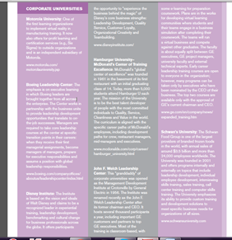

1. ***Assessment*- Personality inventories**are paper and- pencil or Web-based assessment instruments. They are relatively easy to use and can be effective in building individual self-awareness by providing participants with insight into their personal tendencies and values. They can also be used in helping participants appreciate individual differences in others and understand why other people may act the way they do. Personality inventories tend to be popular with participants (i.e., elicit positive reactions) because people generally enjoy learning about themselves.

*For Example*,

* ***The Meyers-Briggs Type Indicator***® is commonly used in leadership development workshops as a way to introduce participants to different personality types.
* ***Multi-source ratings/360-degree feedback***is also a very popular development practice. It involves the systematic measurement of the perceptions of an individual’s leadership performance from an entire circle of relevant viewpoints, including self, subordinates, peers, supervisors and even external stakeholders such as customers and suppliers. Supposedly, such a comprehensive assessment from various role perspectives can provide an accurate picture of the impact of a leader’s behaviour on others. The gap between self ratings and others’ ratings can be used to estimate individual self-awareness, which has been shown to be positively related to managerial performance. A potential weakness of this practice is that the resulting ratings can lead to confusion if they do not converge across rating sources. For this reason, multi-source ratings are most effective when linked with executive coaching.
* ***Assessment centres*** offer a comprehensive method for assessing an individual’s leadership potential. Traditionally, assessment centres have been used for selecting managers for middle- and upperlevel jobs by assessing their skills through different assessment exercises that measure performance across a number of dimensions. Developmental assessment centres are used exclusively for employee development, with a heavy emphasis on assessment with feedback. Specifically, it is a collection of workplace simulation exercises that provide individuals with practice, feedback and coaching on a set of behavioural dimensions that (a) can be developed and (b) are considered to be critical to professional success. Survey results indicate that developmental planning was reported as a popular reason for using an assessment centre (39 percent of responses), following selection (50 percent) and promotion (48 percent).[45] Advantages of developmental assessment centres include that they are thorough and comprehensive and link the important components of assessment, challenge and support. On the downside, they are expensive and time-consuming to design and implement. There is no reliable data to suggest that they are more effective than feedback and coaching on their own.

1. ***Coaching-*Executive coaching**is valuable in helping leaders make sense of their assessment data, putting together an actionable development plan, implementing the plan and providing support and follow-up assessment of behavioural change.

The Individual Coaching for Effectiveness (ICE) model for middle- and higher-level leaders consists of three phases: (1) diagnosis (one or two days of assessment and feedback); (2) coaching (one day per month for six consecutive months); and (3) maintenance/support (periodic contacts and review sessions to help maintain the personal changes.

***Mentoring*** is considered a formal or informal process in which a more senior person takes a vested interest in the personal and professional development of a more junior person, usually a professional colleague. Of particular interest is the finding that informal mentoring programs tend to be more effective and receive more favourable responses than formal programs. There also is recent interest in the issue of “marginal mentoring” that recognizes that not all mentoring experiences are positive or beneficial. It is an unfortunate reality that few leaders get any training on how to be effective mentors even when there is a formal mentoring program in place. Other cautions with regard to mentoring include that it is very time-intensive for both parties and that there may be insufficient numbers of qualified mentors for those in very junior positions. This is why some have advised using mentoring only in targeted situations involving high-potential managers and senior-level executives. In more large-scale applications with junior employees, it may be more realistic to set up *mentoring networks*, in which employees are assisted in identifying existing helpful relationships and then trained in how to better use these relationships for their development.

1. ***Experiential Learning-*Job assignments**have long been favoured as a leadership development practice, especially those assignments that “stretch” the thinking or other capabilities of the target leader. This makes sense in that it is widely believed that leaders view their most potent developmental activities to be experiential based, especially on-thejob experiences. There are two fundamental questions in using job assignments for leader development: (a) how prepared should someone be for a stretch assignment; and (b) what is the right assignment for this leader at this time? It requires an intimate knowledge of the career goals, career paths and developmental readiness of those leaders.

***Action-learning projects*** constitute an approach that is based on the assumption from adult learning theory that people learn most effectively when working on organizational problems in real time. Action learning typically takes place in project teams composed of people from diverse functions and locations working together for six to 12 months on an issue considered to be strategically important to the organization. What makes or breaks action-learning in terms of development is the degree that ongoing learning is valued as much as performing well. External coaches are often used to help facilitate team self-reflections and to enhance learning and development.

*An example* of a successful action learning initiative for the purpose of system-wide leadership development in a non-profit organization is described in “Catholic Healthcare Partners Leadership Academy.”

Research published by Linkage, Inc. indicates that across eight major manufacturing and pharmaceutical firms, the most developmentally potent component of leadership development initiatives is action learning.

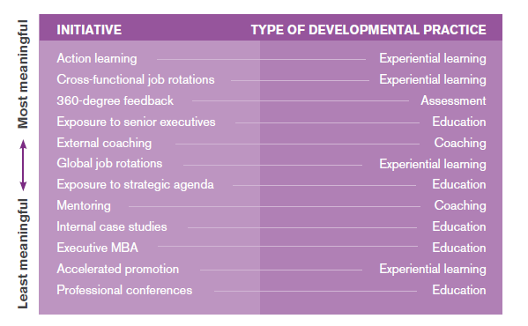

**Conclusion**

Of the four general types of developmental practices, education and experiential learning were represented most often on this list, with assessment and coaching being less represented. Nonetheless,360-degree feedback (assessment) was rated as the third most developmentally potent activitybehind two different forms of experiential practices. The bottom line is that any leadership development initiative must be a logical extension of succession planning, based on the organization’s strategy, and should be feasible given the organization’s size and resources. There are a multitude of possible developmental practices that can be adopted. As noted previously, the goal should not be to choose those practices that have worked in other organizations but rather to choose those that can best serve your purpose. Disciplined implementation and follow-through are more important factors in the success of the initiative than the particular practices that are adopted.

# CCL Leadership Development Initiatives

# CCL provides a flexible suite of development resources targeted to five levels of leaders:

1. **Leading Self -** *Individual contributors, professional staff and emerging leaders*
2. **Leading Others -** *Leaders of individual contributors*
3. **Leading Managers -** *Experienced leaders who lead other managers or senior professional staff*
4. **Leading the Function -** *Senior leaders of organizational functions or divisions*
5. **Leading the Organization -** *Top executives leading the enterprise*

|  |  |  |
| --- | --- | --- |
| **Leadership Level** | **Challenges** | **Required Competencies** |
| **Leading Self** | * + 1. Prepare for management or leadership role     2. Build a common leadership language within an organization     3. Increase personal effectiveness and performance | 1. Establishing credibility 2. Leading with purpose 3. Delivering results 4. Doing whatever it takes 5. Interpersonal savvy 6. Embracing flexibility 7. Tolerating ambiguity 8. Understanding one’s own values and culture |
| **Leading Others** | 1. Transition from individual performer to leading a team 2. Build relationships to get work done 3. Deal effectively with conflict 4. Solve problems successfully | 1. Coaching and developing others 2. Leading team achievement 3. Building and maintaining relationships 4. Resolving conflict 5. Learning to delegate 6. Innovative problem solving 7. Embracing change 8. Adapting to cultural differences |
| **Leading Managers** | 1. Integrate cross functional perspectives in decisions 2. Handle complexity 3. Manage politics 4. Sell ideas to senior leaders 5. Select and lead managers for high performance | 1. Thinking and acting systemically 2. Managing organizational complexity 3. Negotiating adeptly 4. Selecting and developing others 5. Taking risks Implementing change 6. Managing globally dispersed teams 7. Building resiliency |
| **Leading the Function** | 1. Set vision and build toward the future 2. Balance trade-offs between the short and long-term 3. Align the organization for strategy implementation | 1. Being visionary 2. Driving results 3. Strategic thinking and acting 4. Creating engagement 5. Identifying innovation opportunities for new businesses 6. Working across boundaries 7. Leading globally |
| **Leading the Organization** | 1. Set organizational direction 2. Foster alignments across the organization 3. Gain commitment for performance 4. Refine and build strong executive persona | 1. Creating and articulating vision 2. Creating strategic alignment 3. Developing a leadership and talent strategy aligned with business strategy 4. Leading the culture 5. Executive image 6. Creating a culture of innovation 7. Catalyzing change 8. Leading outwardly |

# Assessment Techniques for Development

**SHL OPQ32 Emotional and Social Competence Report**

* ***Assessing Emotional Intelligence in the workplace***

There is growing evidence that emotionally intelligent leaders achieve superior work place out comes. Many organisations are focusing on selecting individuals who possess high levels of Emotional Intelligence (EI), and developing the EI of existing leaders.

* ***What is Emotional and Social Competence?***

Emotional Intelligence (EI) is not a new concept; it is simply a new framework within which important behaviours are now being evaluated. The model of Emotional and Social Competence on which the report is based combines 5 competencies that form EI.

* ***How can EI be measured best?***

Numerous studies, including extensive research by Melbourne psychologists Ian Kendall and Richard Want of Kendall Want & Associates, demonstrate that emotional and social competencies embedded in personality – and it is possible to tap into the specific factors of EI that effect work performance. Their research has shown that the most important EI dimensions can be assessed using the Occupational Personality Questionnaire (OPQ32). As a result the Emotional and Social Competence report has been developed to assess EI specifically in the workplace. EI can also be developed – the Emotional and Social Competence Report can be used in conjunction with other assessment tools such as 360° feedback to facilitate development planning.

* ***The OPQ32 Emotional and Social Competence (ESC) Report***

The new OPQ32 Emotional and Social Competence (ESC) report is based on Daniel Goleman’s theory of Emotional Intelligence. It indicates strengths and development needs for the individual, and consists of a Competency Profile Chart for the 20 competencies assessed, a rating summary; and positive, moderate and negative indicators for each competency.

* ***Which competencies does the report assess?***

**Emotional Competence**

|  |  |
| --- | --- |
| **Area** | **Competency** |
| Self-Awareness | Emotional Awareness  Accurate self assessment  Self-Confidence |
| Self-Regulation | Self-Control  Conscientiousness  Adaptability |
| Motivation | Achievement Drive  Initiative  Persistance |

**Social Competence**

|  |  |
| --- | --- |
| **Area** | **Competency** |
| Empathy | Understanding Others  Service Orientation  Organisational Awareness |
| Social Skills | Influence  Communication  Conflict Management  Leadership  Change Catalyst  Building Bonds  Developing Others  Teamwork and Collaboration |

* ***How can the ESC Report be applied?***

Professional Development and Coaching

The report provides valuable information for coaching purposes and can be used in conjunction with other tools, such as 360° feedback, to make links between individual preference and style and the perceptions of others**.**

## Hogan Assessment

Hogan assessments are used for a variety of talent management initiatives like Predicting Job Performance, Evaluating Career Derailers, Identifying Potential, Leadership Development and using performance indices like 360° process.

Hogan’s four assessments offer the measurement indices required to understand people’s strengths, weaknesses, values, and approach to problem solving and accurately predict performance.

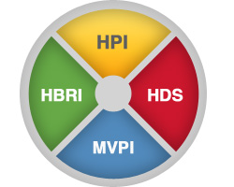

The **Hogan Personality Inventory (HPI)** measures normal personality characteristics necessary for job fit, effective relationships, and career success. The HPI measures normal personality along seven scales:

* Adjustment: confidence, self-esteem, and composure under pressure
* Ambition: initiative, competitiveness, and desire for leadership roles
* Sociability: extraversion, gregarious, and need for social interaction
* Interpersonal Sensitivity: tact, perceptiveness, and ability to maintain relationships
* Prudence: self-discipline, responsibility, and thoroughness
* Inquisitive: imagination, curiosity, and creative potential
* Learning Approach: achievement orientation, valuing education

The HPI measures six occupational scales that predict performance in a specific role:

* Service Orientation: attentiveness and courteousness toward customers
* Stress Tolerance: composure, calm under pressure
* Reliability: honesty, positive organizational citizenship
* Clerical Potential: self-discipline, meticulousness, and the ability to communicate clearly
* Sales Potential: energy, social skills, and the ability to solve problems for customers
* Managerial Potential: leadership ability, planning, and decision-making skills

The HPI was developed specifically for business applications, and identifies the personality characteristics that distinguish individuals and predict career success, making it a powerful tool that can be used throughout the employee lifecycle.

***Selection****:* Selection reports fuelled by the HPI inject valuable insight into the hiring process, from measuring candidates’ job fit to highlighting specific areas of strengths and weaknesses.

***Development****:* HPI-driven development reports offer actionable management and development suggestions to help organizations guide careers and development.

***Leadership****:* Leadership reports offer detailed development advice to help organization leaders play to their strengths

The **Hogan Development Survey (HDS)** is the industry standard for measuring career derailing personality characteristics. The HDS measures dark side personality along 11 scales:

* Excitable: moody, hard to please, and emotionally volatile
* Skeptical: suspicious, sensitive to criticism, and expecting betrayal
* Cautious: risk averse, resistant to change, and slow to make decisions
* Reserved: aloof, uncommunicative, and indifferent to the feelings of others
* Leisurely: overtly cooperative, but privately irritable, stubborn, and uncooperative
* Bold: overly self-confident, arrogant, and entitled
* Mischievous: charming, risk-taking, and excitement-seeking
* Colorful: dramatic, attention-seeking, and interruptive
* Imaginative: creative, but thinking and acting in unusual or eccentric ways
* Diligent: meticulous, precise, hard to please, and micromanaging
* Dutiful: eager to please and reluctant to act independently or against popular opinion

The HDS identifies the dark-side personality characteristics that can erode relationships and derail people’s chances of success, making it a powerful tool that can be used throughout the employee lifecycle.

***Selection****:* Selection reports fuelled by the HDS inject valuable insight into the hiring process, from measuring candidates’ overall desirability to highlighting specific areas of strengths and weaknesses.

***Development****:* HDS-driven development reports offer actionable management and development suggestions to help organizations guide their employees’ careers.

***Leadership***: HDS reports provide leaders the tools they need to understand their strengths and weaknesses, and how they compare to those of their peers.

The **Motives, Values, Preferences Inventory (MVPI)** reveals a person’s core values, goals, and interests, which impact organizational fit and indicate environments in which individuals will be motivated and satisfied.The MVPI measures values along 10 primary scales. High scorers are described as:

* Recognition: responsive to attention, approval, and praise Power: desiring success, accomplishment, status, and control
* Hedonism: orientated for fun, pleasure, and enjoyment
* Altruistic: wanting to help others and contribute to society
* Affiliation: enjoying and seeking out social interaction
* Tradition: dedicated to strong personal beliefs
* Security: needing predictability, structure, and order
* Commerce: interested in money, profits, investment, and business opportunities
* Aesthetics: needing self-expression, concerned over look, feel, and design of work products
* Science: wanting knowledge, research, technology, and data

The MVPI measures five item themes that predict culture fit in an organization.

* Lifestyles: concern the manner in which a person would like to live
* Beliefs: involve ideals and ultimate life goals
* Occupational Preferences: include an individual’s preferred work, and what constitutes a good job
* Aversions: reflect attitudes and behaviour that are disliked or distressing
* Preferred Associates: concern the kind of person desired as co-workers and friends

Values impact every aspect of peoples’ careers. The MVPI helps us understand what motivates people to succeed and in what type of position, job, and environment they will be the most productive, making it a powerful tool that can be used throughout the employee lifecycle.

***Selection****:* Selection reports fuelled by the MVPI inject valuable insight into the hiring process by determining whether candidates’ values are a good fit for their job, work group, or company.

***Development****:* Understanding what drives people to succeed gives organizations valuable managerial insight to help guide their employees’ careers.

***Leadership****:* Helps leaders understand how their unconscious biases are likely to influence their decisions about people and projects, and the type of corporate culture their values are likely to create

The **Hogan Business Reasoning Inventory (HBRI)** evaluates a person’s ability to solve real world problems and make business-related decisions using textual, graphic, and quantitative data. The first measure of reasoning ability designed to predict real-world performance, the HBRI evaluates two kinds of problems solving: tactical and strategic reasoning.

* Tactical Reasoning: the ability to solve problems and come to sensible conclusions once the facts are known. High scorers tend to be disciplined, steady, and precise.
* Strategic Reasoning: the ability to detect errors, gaps, and logical flaws in graphs, memos, diagrams, written reports, numerical projections, and tables of data. High scorers tend to be curious and interested in feedback.

The HBRI was developed specifically for the business community, and identifies differences in problem-solving style and reasoning ability that distinguish individuals and predict career success, making it a powerful tool that can be used throughout the employee lifecycle.

***Selection****:* Reports using the HBRI measure candidates’ capacity to evaluate data, identify problems, and make business-critical decisions.

***Development****:* Helps candidates play to their strengths, and understand areas in which focused development can improve their capacity

***Leadership***: HBRI-driven leadership reports help understand how organization leaders will approach problems and make decisions that could affect the company’s future viability.

## Hogan Tools

**HoganDevelop**

***Career***The Career Report identifies how people will act in various business circumstances, identifies their strengths and shortcomings, and includes detailed tips to help manage their careers.

***Compass*** The Compass Report identifies employees’ core values, compares them with various occupations and cultures, and describes the type of environment in which they will be comfortable working and living.

***EQ***The Hogan EQ Report assesses emotional intelligence, the ability to identify and manage your own and others' emotions. Based on the Hogan Personality Inventory and Hogan Development Survey, the report provides an overall EQ score, as well as scores and feedback for six emotional competencies. The report also includes a summary of likely behaviours, score pros and cons, and discussion points.

***Flash***The Flash Report graphically displays Hogan Personality Inventory, Hogan Development Survey, and Motives, Values, Preferences Inventory scale scores and provides raw data for HPI and MVPI subscales. The report is designed for use by a coach or user with expertise to interpret based on numbers alone.

***Hogan 360***The Hogan 360° Report is a comprehensive multi-rater feedback tool designed to help career-minded individuals and leaders at any level of an organization gain a better understanding of how they are perceived by managers, peers, direct reports, and others. The report uses an easy-to-interpret leadership framework to provide a real-time look at an individual's attitude, behaviour, and performance. Commonly used for development purposes, the report offers constructive feedback and sets priorities for improvement.

***Insight Series***The Insight series provides organizations with scientifically validated information about an individual's strengths, performance risks, and core values. Used as a feedback tool for development, the report gives emerging and mid-level managers the self-awareness needed to perform effectively. Based on Hogan's trademark assessments, the three-part series includes reports derived from the Hogan Personality Inventory, Hogan Development Survey, and Motives, Values, Preferences Inventory.

***Manage***The Manage Report provides effective techniques for managing employees based on their personalities. It identifies employees’ strengths, as well as their potential shortcomings.

***Management Focus***Hogan’s Management Focus Report helps first-time managers and supervisors understand how their personality characteristics may influence their managerial approach. The report provides valuable insights into day-to-day characteristics and core value drivers so participants can leverage strengths, manage challenges, and increase their overall managerial effectiveness.

***Safety***The Safety Report for development provides a graphic summary and interpretation of a candidate’s safety-related behaviour. These results outline strengths and areas of concern relating to a general employment fit for a particular work environment.

**HoganLead**

***Leadership Forecast Series***The Hogan Leadership Forecast Series includes four development-focused reports. Based on the Hogan Personality Inventory, Hogan Development Survey, and Motives, Values, Preferences Inventory, each report offers information regarding the characteristics, competencies, and values that underlie how a leader approaches work, leadership, and interaction with others in the workplace.

***Potential***The Potential Report outlines the day-to-day leadership style, describes behaviours typically associated with that style, leadership competencies, and comprehensive development recommendations.

***Challenge***The Challenge Report describes how leaders are likely to interpret the world and treat subordinates while under stress and pressure. The Challenge Report predicts career-derailing behaviours that interfere with the ability to build a cohesive and high-performing team.

***Values***The Values Report explores the core values and goals that ultimately drive a leader's behaviour, aspirations, and expectations about life. What people value determines how they will lead; this determines the kind of environment a leader will create and the sort of organizational culture in which the person will do the best work.

***Coaching***The Coaching Report is a self-guided, comprehensive development-planning tool for individual leadership development. The Coaching Report integrates the information from the Potential, Challenge, and Values reports into a five-step planning process. By completing this process, a leader produces a powerful, personal development plan designed to foster professional growth.

***Summary***The Summary Report is an overview of a candidate’s strengths, challenges, and values. The report integrates results across the HPI, HDS, and MVPI to provide a snapshot of interpersonal performance and values in relation to future career aspirations.

## CCL Assessment Tools

CCL assessment and feedback process helps leaders measure where they are clarify needs and goals and set direction for further development.

**Advantages of CCL Assessment Tools:**

1. Easily fit into existing organizational development programs and offer relevant observable and measurable results on leadership skills managers learn through experience.
2. Provide options for customization that can increase relevance, ownership and advocacy throughout the organization.
3. Provide statistically valid and reliable results that help individuals and teams align their performance objectives with those of the entire organization.
4. Provide language options for use with non-English speaking employees.

**There are three types of Assessment tools:**

**360 degree Assessments**

360-degree feedback is a method of systematically collecting opinions about an individual's performance from a wide range of co-workers. This could include peers, direct reports, the boss, and the boss’s peers— along with people outside the organization, such as customers. The benefit of collecting data of this kind is that the person gets to see a panorama of perceptions rather than just self-perception, which affords a more complete picture.

Following are some of the Assessment tools under 360 degree feedback by CLC:

* **Executive Dimensions**

The challenges faced by executives at the top levels in an organization can differ a great deal from those at the middle management level. Executive Dimensions is a 360-degree assessment designed to address the specific leadership issues of top-level executives. These individuals see their feedback data compared to an exclusive normative base of other top executives. Unlike other assessments that contain normative data encompassing all users, Executive Dimensions data are screened to ensure that only the very top-level leaders are included in the normative base.

* **Results:**
  + Provides top-level executives with feedback on specific, critical leadership skills
  + Helps individuals compare their results to other senior leaders
  + Starts the process of feedback-based individual development
* **Content:**
  + It measures a total of 16 competencies under 3 different headers. These are listed in the table below:

|  |  |  |
| --- | --- | --- |
| **Leading the Business** | **Leading others** | **Leading by Personal Example** |
| 1. Sound judgment 2. Strategic planning 3. Leading change 4. Results orientation 5. Global awareness 6. Business perspective | * Inspiring commitment * Forging synergy * Developing and empowering * Leveraging differences * Communicating effectively * Interpersonal savvy | * Courage * Executive image * Learning from experience * Credibility |

**Sample Report:**

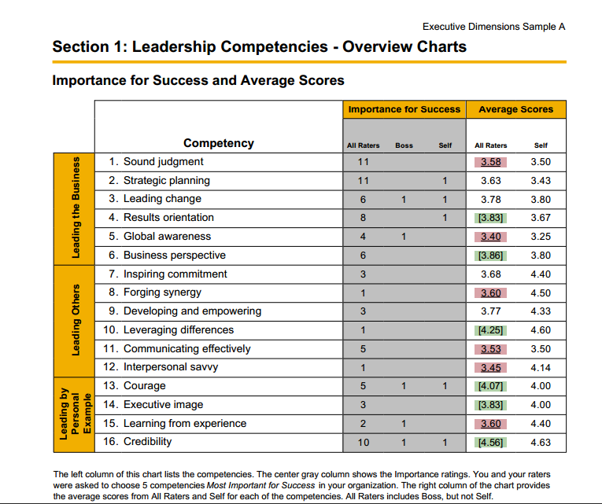

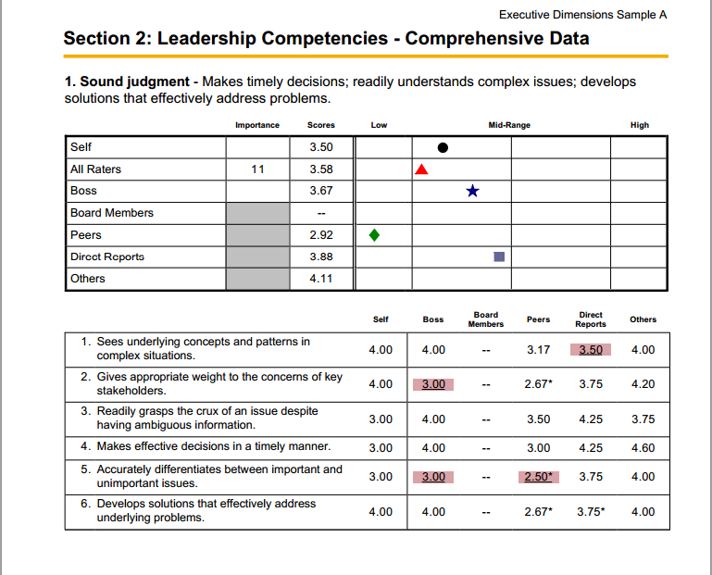

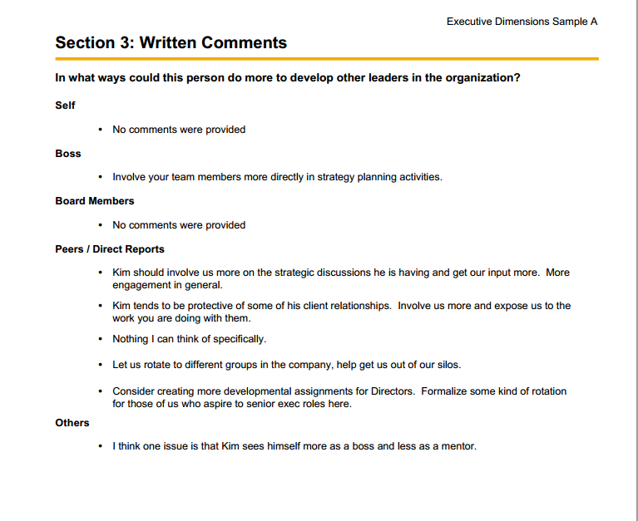



* **Benchmarks**

Benchmarks is a comprehensive 360-degree assessment for middle to upper-level managers that measures 16 competencies critical for success, as well as five possible career de-railers. This in-depth analysis of observable behaviours provides managers with a solid assessment of their leadership competencies. Benchmarks also helps managers identify what lessons may still need to be learned, establishes what specific work experiences need to be sought out in order to develop critical competencies for success, and identifies possible problems that may stall their career.

* **Results:** 
  + Shows how others perceive strengths and development needs
  + Provides normative comparison of results with other successful managers
  + Starts the process of feedback-based individual development
* **Content:**
  + Benchmarks measures the 16 competencies and 5 derailment factors listed below, containing a total of 130 items. The feedback report displays results grouped into 4 categories. These are given in the table below:

|  |  |  |
| --- | --- | --- |
| **Leading the Organization** | **Leading Others** | **Leading Yourself** |
| * Strategic perspective * Being a quick study * Decisiveness * Change management | * Leading employees * Confronting problem employees * Participative management * Building collaborative relationships * Compassion and sensitivity * Putting people at ease * Respect for differences | * Taking initiative * Composure * Balance between personal and work life * Self-awareness * Career management |

* **Sample Report**

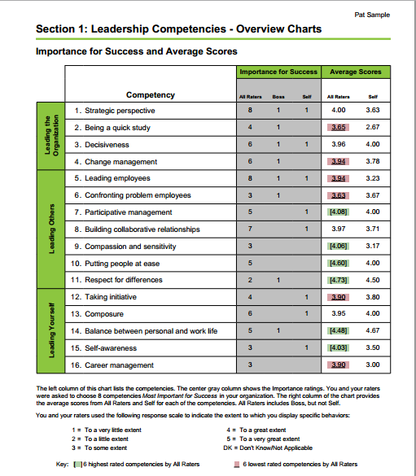

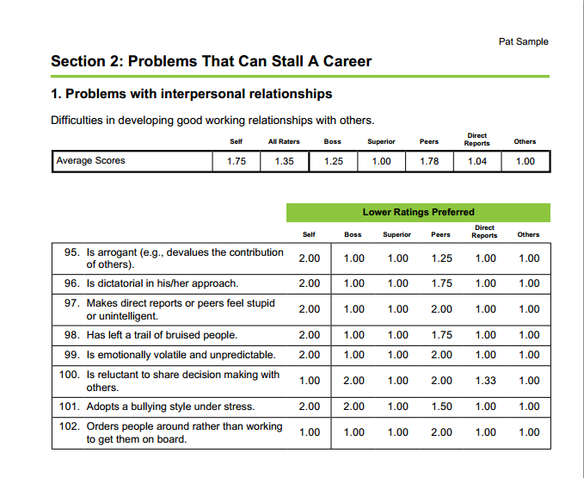

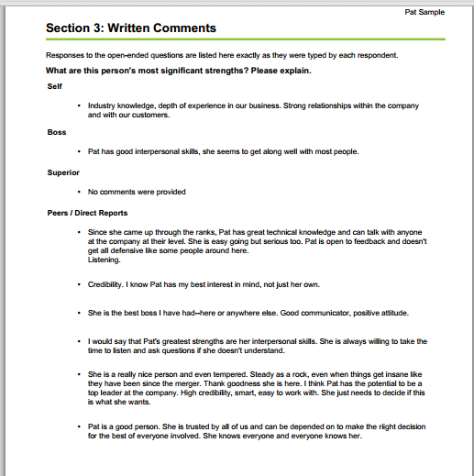

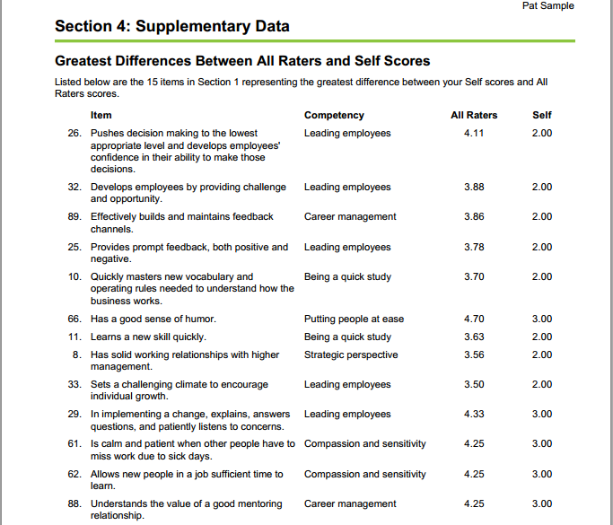

* **Prospector**

Prospector is a 360-degree assessment that provides feedback on two areas of behaviours: the skills most often found in successful leaders, and the learning behaviours needed to acquire those skills. Prospector can be used with high-potentials, individual contributors, and managers. The research behind Prospector shows that in order to be successful, individuals must be willing to learn from new experiences and have the ability to apply what they learn to workplace challenges. The ability to learn from experiences is a critical predictor of success as a leader.

* **Result** :
  + Provides important feedback on skills that help managers improve their ability to learn from experience and willingness to take advantage of growth opportunities.
  + Helps establish a culture in which improved learning skills are recognized and highly valued as an overall organizational objective.
  + Helps high-potential managers identify the skills they will need to succeed as they advance in the organization.
* **Content** :
  + Prospector measures the leadership skills most often found in successful leaders and the learning behaviours needed to acquire those skills. The feedback report displays results grouped into two categories. These categories represent 11 competencies, containing a total of 48 items. These are given in the table below:

|  |  |
| --- | --- |
| **Learning to Learn** | **Learning to Lead** |
| * Seeks opportunities to learn * Seeks and uses feedback * Learns from mistakes * Open to criticism | * Committed to making a difference * Insightful - sees things from new angles * Has the courage to take risks * Brings out the best in people * Acts with integrity * Seeks broad business knowledge * Adapts to cultural differences |

* **Sample Report:**

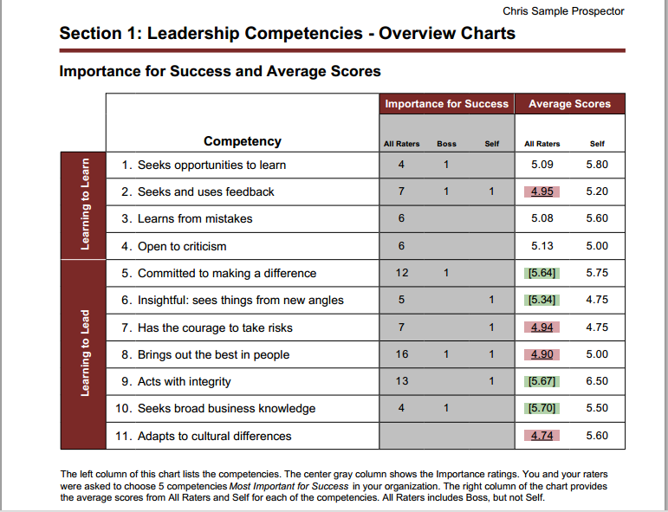

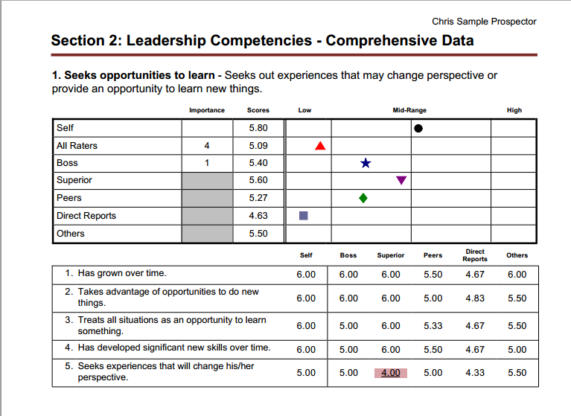

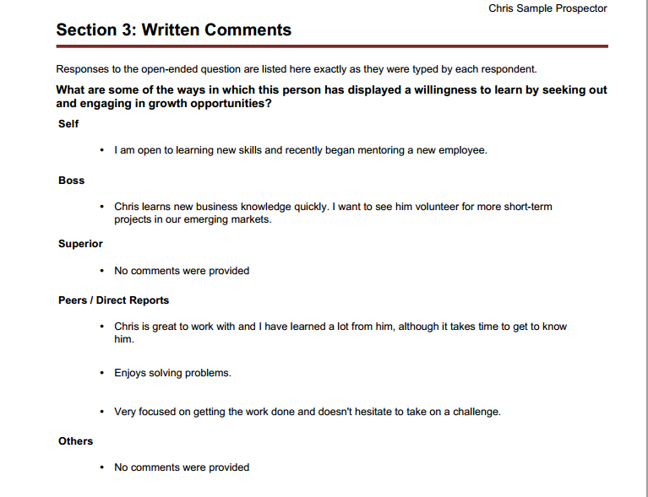

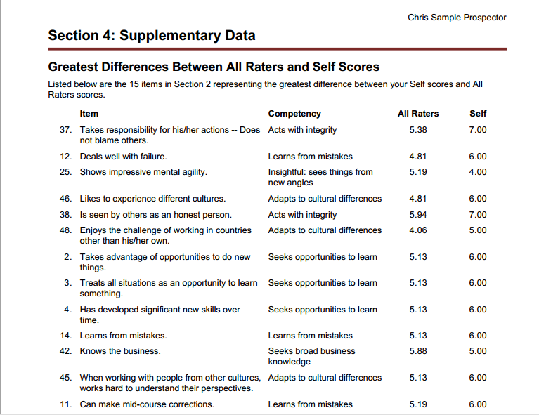

**Self Assessments**

A self-assessment is completed by the individual being assessed. Self assessments can provide immediate insight into:

* Moving towards a more productive and sustainable way of managing the boundaries between work and family
* Understanding leadership characteristics
* Using job assignments to develop valuable skills
* Articulating preferred learning behaviours and styles

Following are the tools provided by CLC for self assessments:

**Work life indicator**

Work Life Indicator is a self-assessment that measures an individual's approach for managing the boundaries between work and family. The integrated individual feedback report and development planning guide provide concrete strategies and tips to increase effectiveness and engagement.

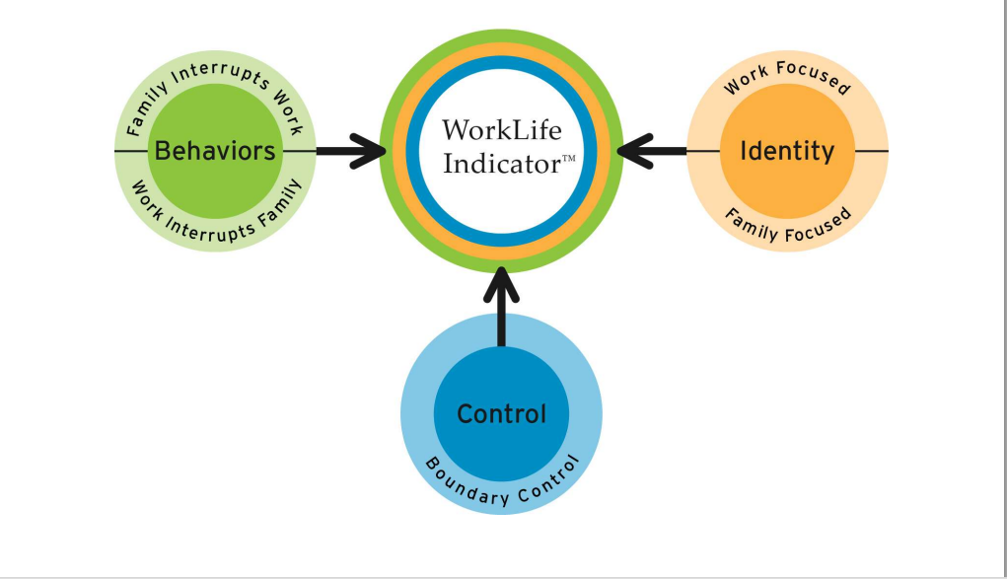

* **Results:** 
  + Understand how an individual currently manages the boundaries between work and family
  + Become aware of other approaches for managing boundaries
  + Identify choices in managing the boundaries between work and family
  + Understand how strongly an individual identifies with work and family roles
  + Articulate how much control an individual feels in choosing how to manage the boundaries between work and family
  + Develop a plan to increase effectiveness on and off the job
* **Content**: It measures three factors. These are:
  + Behaviours — the degree to which individuals combine or separate work and family life
  + Identity — the degree to which individuals identify with and invest themselves in work and family roles
  + Control — the degree to which individuals feel in control of how they manage the boundaries between work and personal life
* **Sample Reports:**

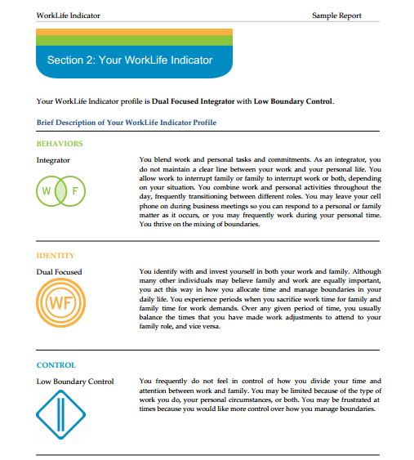

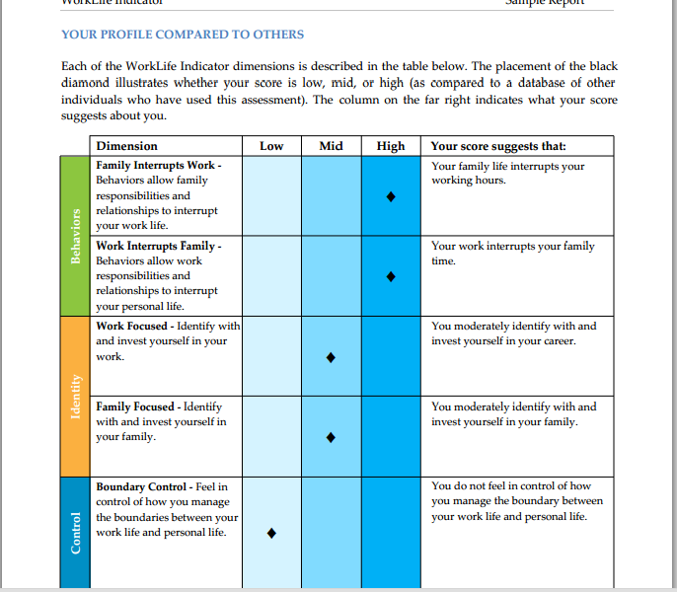

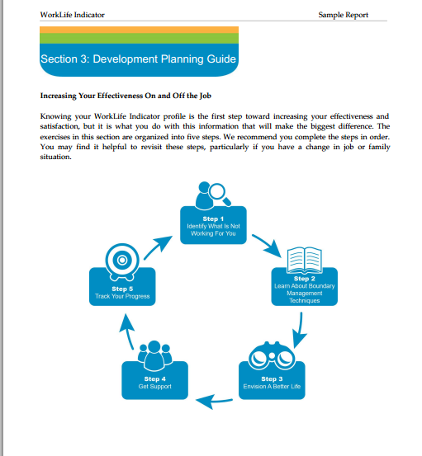

**Campbell Leadership Director**

A self assessment designed to help individuals identify characteristics for successful leadership, recognize their strengths and identify areas for improvement.

* **Results:** 
  + Participants evaluate leadership strengths and areas needing improvement by comparing personal leadership attributes to those of a "good leader" and a "poor leader" whom an individual has known.
  + Participants develop a personal action plan for strengthening leadership effectiveness.
* **Content:** It assesses the following :
  + Vision, Diplomacy, Personal Style, Management, feedback, Personal Energy, Empowerment, Entrepreneurialism, Multicultural assessment.

**Job Challenge Profile**

A self-assessment tool designed for managers and executives to help them understand and use their job assignments as opportunities to develop valuable skills.

* **Results:** It helps participants:
  + Gauge the challenges in their jobs
  + Turn challenges into prime learning experiences
  + View their current job as a learning opportunity
* **Content:** It measures five clusters of job components that represent major aspects of managerial work:
  + Experiencing a job transition
  + Creating change
  + Managing high levels of responsibility
  + Managing boundaries
  + Dealing with diversity

**Learning Tactics Inventory**

A tool designed for participants who wish to become better at learning from experience. The LTI profiles a person's preferred learning behaviour, outlines the consequences of overuse of each tactic, and explores ways to adopt new learning strategies and behaviours.

* **Results:** Enables participants to:
  + Identify their preferred learning profile and behaviours
  + Develop tactics to improve learning effectiveness
  + Create learning goals that improve performance
* **Content:** The Learning Tactics Inventory addresses two questions associated with thepractice of learning managerial and leadership skills:
  + Why do some people learn from the opportunities of the workplace, while others fail?
  + Can individuals improve their ability to learn from experience?

**Organizational Assessments**

Team and organizational assessments provide insight into aspects of leadership and the work environment that impact workgroup performance. Assessments offered by CCL can help teams and organizations assess the climate for creativity and innovation and identify strengths and weaknesses.

Following are the tools provided by CLC for organization assessments:

**Leadership Gap Indicator**

Leadership Gap Indicator is a team and organizational assessment designed to help the organization identify the effectiveness of current leadership skills and draw attention to leadership gaps that may exist. It provides organizations with a tool for evaluating managers' opinions about development needs.

* **Results:** It helps organizations
  + Discover the specific leadership skills essential to the success of your organization
  + Understand which set of competency areas, unique to your organization, are most important now and in the future
  + Recognize the leadership competency gaps that need to be addressed
  + Diagnosis talent training needs
* **Content:** Managers rate the importance of leadership competencies for success now and in the future, and then rate the abilities of their peer group to perform them. By identifying any gaps between today's skills and those required for future success, organizations will have the data they need to begin making strategic plans for developing leadership talent. It gives a measure on 20 competencies and 5 derailment factors.

|  |  |  |
| --- | --- | --- |
| **Leadership Competencies** | | |
| * Leading employees * Building collaborative relationships * Career management * Change management * Compassion & sensitivity * Confronting problem employees * Decisiveness | * Respect for differences * Taking initiative * Balancing personal life & work * Participative management * Putting people at ease * Being a quick learner * Strategic perspective | * Self-awareness * Composure * Employee development * Strategic planning * Culturally adaptable * Inspiring commitment |

|  |
| --- |
| **Derailment Factors** |
| * Difficulty building and leading a team * Difficulty changing or adapting * Failure to meet business objectives * Problems with interpersonal relationships * Too narrow functional orientation |

* **Sample Reports**: The report throws light on the following :

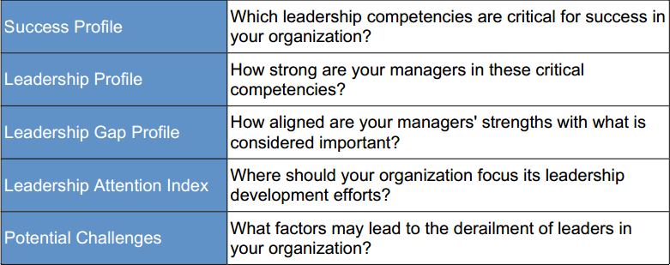

**Keys to creativity and innovation**

KEYS to Creativity and Innovation is a team and organizational assessment that measures the climate for creativity and innovation that exists in a work group, division or organization. It assesses the work environment; specifically the management practices, resources, motivations and interactions. It can be used to jump start creativity, to communicate the importance of creativity and innovation within an organization and as an assessment preceding any type of innovation or change intervention.

* **Results:** 
  + Reveals pockets of excellence as well as areas with critical development needs when comparing categories such as departments, functions, or locations.
  + Identifies the most important factors that support or inhibit innovation and creativity.
  + Provides suggestions for improving the climate for creativity and innovation.
  + Provides hard data needed to develop the innovative culture within and across business.
* **Content:** The 78 items on KEYS are organized into 10 work environment dimensions. Of these, 4 describe management practices, 2 describe organizational motivation to creativity, and 2 describe resources. The remaining 2 dimensions describe perceptions of outcomes—the creativity and productivity of the work actually being done in the organization.

|  |
| --- |
| **Management Practices** |
| * **Freedom:** Deciding what work to do or how to do it; a sense of control over one's work * **Challenging Work:** A sense of having to work hard on challenging tasks and important projects * **Managerial Encouragement:** A boss who serves as a good work model, sets goals appropriately, supports the work group, values individual contributions, and shows confidence in the work group * **Work Group Supports:** A diversely skilled work group in which people communicate well, are open to new ideas, constructively challenge each other's work, trust and help each other and feel committed to the work they are doing |

|  |
| --- |
| **Organizational Motivation** |
| * **Organizational Encouragement:** An organizational culture that encourages creativity through the fair, constructive judgment of ideas, reward and recognition for creative work, mechanisms for developing new ideas, an active flow of ideas and a shared vision * **Lack of Organizational Impediments:** An organizational culture that does not impede creativity through internal political problems, harsh criticism of new ideas, destructive internal competition, an avoidance of risk and an overemphasis on the status quo |

|  |
| --- |
| **Resources** |
| * **Sufficient Resources:** Access to appropriate resources, including funds, materials, facilities and information * **Realistic Workload Pressures:** Absence of extreme time pressures, unrealistic expectations for productivity and distractions from creative work |

|  |
| --- |
| **Outcomes** |
| * **Creativity:** A creative organization or unit, where a great deal of creativity is called for and where people believe they actually produce creative work * **Productivity:** An efficient, effective and productive organization or unit |

This section covers the following various company examples of what and how assessment techniques for promotion and development of employees are used. We interviewed various HR professional in these companies through the questionnaire (please find below) to collect data.

* Deutsche Bank
* Mahindra Comviva
* Crompton and Greaves
* Sutherland Global Services
* Ranbaxy

**QUESTIONNAIRE**

1. Does a structured process exists for selecting candidates for promotion and development?
2. What are the various ways to assess employees for promotion in your firm? (how many techniques used, ,2/3 lines description of each tool, duration of each tool, who are the assessors, what and how many competencies assessed through each tool, any other detail about the tools used )
3. What are the different assessment techniques used in your organization for development of employees? (same details as previous question) Also discuss the underlying talent management philosophy.
4. For development of employees, are there development centres? If yes, when does the assessment takes place, duration of development center and of each activity, how many techniques used, ratio of assessor and assesse, any other details?
5. Are the programs in-house or external ?
6. How are employees nominated for such programs of promotion and development?
7. Do you use different techniques for different hierarchical levels (eg middle level and senior level management)? If yes, list down.
8. Do you think the assessment tools used , test the employee on everything which they are required to be tested on? If yes/not, which ones ?
9. What are the pros and cons of the assessment techniques you use?
10. How have you tested the validity of these assessment tools?
11. Are the employees trained beforehand on how to use these assessment tools?
12. How often are the assessment techniques relooked at, considering the changing needs of the organisation?
13. Promotion and development exercise is carried out by whom? (composition of team)
    1. **Assessment techniques for Promotion and Development of Employees in Deutsche Bank**

There are 9 grades in Deutsche

1. Managing director

Promotion and development plans for mainly grade 5 and above

1. Director
2. Vice President
3. Assistant vice president
4. Associate
5. Analysts- entry level (no separate program for promotion and development is there as no relevant experience)
6. Sales

Sales guys/fresh graduates- 9 grades are in retail/pubic banking

1. Sales
2. Sales

**Process of promotion and development is done-**

1. Identifying key talent through -
2. **Talent rating through 9 box grid** (4x3 grid)-reason of 4x3 grid because a lot of them tend to put in middle level a lot

Potential

Performance

1. **General performance appraisal cycle**- this is mainly for all levels and based on three main objectives-

All these 3 objectives have “what” and “how” aspect to it and is based on value systems of Deutcshe

1. Managing people
2. Business objectives (concerned with numbers)
3. Overall objectives

The above two ways are consistent across the organization but some departments may follow other tools also. For eg. In operations world, key talent identified is given extra projects to work upon and then their performance is assessed.

1. Once the key talent is identified, next step is discussions with employees and their managers A gap analysis is done using role framework (based on job and not skill) as to find out where the employee is and where he/she wants to be

Along with all this, **a learning track** is also created for employees to assess two kinds of gaps-

1. Visibility gap (to move upward, need to be more visible)- put employees in regional meeting
2. Soft skills gap –training is recommended. There is a repository online having more than 1 lakh training programs. The training is done in training centre of Deutsche called “centre of excellence” but managed by outside vendors.
3. After that, career planning is done using a development tool called career development plan (which can be done horizontally or diagonally)
4. Succession planning report has three aspects to is-
5. Past performance

3 indicators for it-

* Skills required to work on current role
* Best fit for role
* Ready to move onto the next role

1. Potential
2. Progress
3. Depending upon the requirement, either the person is moved into the next role or given a new project

Duration: Can be a year-long process

**Pros and cons of tools used**

|  |  |
| --- | --- |
| CONS | PROS |
| 1. Small bank with niche role 2. Difficult to move people around 3. Relatively a new bank in India (3 years old)- 4. In Germany it is a unionised set-up- can’t simply send people from India to Germany 5. Not many tools used 6. Tools Not changing very fast 7. Expectation mapping (may cause disillusionment of expectations) 8. In some areas like sales banking-relatively difficult | 1. Simple 2. Easy to understand and implement 3. Prime focus giving maximum onus to employees 4. clear discussions, clarity in expectations set 5. Future focus-  * Competency framework becoming concise day by day * Rolling out skill-based framework |

* 1. **Assessment techniques for Promotion and Development of Employees at Crompton and Greaves**

**Company Overview**

CG is a USD 2 billion engineering conglomerate with an impressive and diverse portfolio of products, solutions and services ranging from high-end power and industrial equipment and solutions, to consumer products and home appliances, addressing myriad needs

**Assessment Tools for Promotion**

**Competency Mapping @ Crompton Greaves**

By conducting a competency mapping exercise, cg has identified 7 competencies. These competencies form the basis for all hiring as well as promotion decisions.

The 7 competencies are

* Result orientation,
* Strategic, customer,
* Cultural sensitivity,
* Change readiness,
* People managemnt,
* Building partnerships and knowlegde
* Innovation

|  |  |  |
| --- | --- | --- |
| Sl. No. | Competency | Definition |
| 1 | Result Orientation | People demonstrating this competency drive for improvement of business results  People with this competency demonstrate passion, drive and commitment to set, meet and exceed goals consistently by quality execution to achieve continuous improvement in business results. |
| 2 | Strategic Orientation | People demonstrating this competency understand the business environment and look out for opportunities and associated risks to further enhance business results with a long term and strategic focus. It demands in-depth understanding of the business and its environment, critical analysis and integration of information to develop and communicate an action-oriented plan in line with Business BHAGs. |
| 3 | People Management | People demonstrating this competency shows the ability to drive performance by setting clear expectations, building effective groups, empowering others and providing ongoing feedback/coaching developing capability and nurturing self and others for future roles. |
| 4 | Inter-Cultural Sensitivity | People demonstrating this competency respect and appreciate the capabilities, insights, and ideas of individuals with diverse style, ability, and motivation and are able to work effectively by crossing and bridging different national, ethnic, organizational, functional or business cultures. |
| 5 | Knowledge and Innovation | People demonstrating these competencies are able to acquire and share knowledge expertise and best practices; experiment and innovate to create new creative business solutions. |
| 6 | Building Partnerships | People demonstrating this competency are effective in building and maintaining productive business/professional relationships with various stakeholders based on trust in the course of accomplishing individual / team / business objectives, to positively impact business performance. |
| 7 | Customer Orientation | People demonstrating this competency think about serving and building value-added relationships with a customer or client, be they internal or external. This competency can be applied to internal or external customers. |

For assessing the competencies a mixture of BEI and competency based interview is followed. Employees are rated on a 3-point scale:

1: employee is often seen to demonstrate the competency across various situation

2: emplyee is somewhat seen to demonstrate the competency in certain situation but fails to maintain a consistenet display of competency

3: employee does not seem to possess the competency and does not display the competency in any situation

The proficiency level of each competency differs across various levels. i.e for the same competency an executive can have a rating of 3 but a manager must have a rating of 1.

Nine box grid:

The company makes use of the 9 box grid to identify its promotable employees. To be able to qualify for promotion an employee must have spent a minimum of 2 years with the organization.

Promotion at lower levels is tenure based as well as vacancy based. However, at higher levels merit takes precedence over tenure.

The 9 box grid comprises of 2 parts:

1. Potential: Potential for the next role is assessed by competency based assessment.
2. Performance: Performance Management is done using the Balance Score Card approach.

**Assessment Tools for Development**

There are three types of Development Programs at C and G

1. Excom Conclave: It is a full day program and is attended by the CEO and his direct reports. It aims to equip the executives with tools that make them better strategy makers.
2. Gloabal Leadership Development Program: This is an aspirational program and is attended by the Hi potential employees. Managers nominate employees for this program. The potential data is captured by competency based interview, and the developmental data is captured through PMS.
3. Behavioural and Technical Program: Under this program, Developmental needs are identified by the annual TNI process and employees are imparted trainings based on their needs. The purpose of this program is to cover as many people as possible.
   1. **Assessment techniques for Promotion and Development of Employees at Mahindra Comviva**

**Company Overview**

**Core Purpose**: To enrich the lives of over a billion people with mobile solutions beyond VAS.

**Intent:** To be the No.1 integrated VAS solution provider in our chosen markets. We will achieve this by creating customer value, built upon a foundation of innovation, excellence and partnerships.

**Values:** Mahindra Comviva is driven by its credos. Above all, Mahindra Comviva values customer centricity, people focus, responsiveness, integrity and excellence.

* **Mahindra Comviva Quick Facts**
  + Formed in 1999, has grown rapidly to become a recognized leader in the provision of integrated VAS solutions to the mobile world.
  + Leverages its local market expertise and know-how in multitude of locations to provide a differentiated portfolio of offerings across the globe
  + Adopted both organic and inorganic mode of growth
  + In 2002, ABC LTD. merged with CellCloud Technologies
  + In late 2007, ABC LTD. acquired Jataayu Software Limited, a leading player in the mobile Internet space
  + Solutions deployed by over 130 operator customers in over 90 countries.
  + Highly Scalable Solution - 0.5 MN to 100 MN Subs
  + 1700+ employees in 15 countries with engineering centers in Bangalore / Delhi.
  + 200 + Strong customer facing team e.g. support and operations in MEA
  + Based in India, with presence in Asia, Europe, MEA and the CALA region
  + Very balanced regional portfolio

**Competency Mapping at Mahindra Comviva**

The organization has begun to emphasize on competency mapping and person-role fit right from the stage of talent entry. Competency based hiring is done to identify if the potential employees have the right set of competencies. Interviews conducted are highly competency driven and intensive.

The organization has developed its own framework, which is a role wise behavioral competency matrix.

1. The organization has divided its employees into various grades.
2. These grades run from A1 to A13
3. Competencies have been identified for each grade cluster which typically forms role levels which are identified as Individual Contributor, Team Lead, and Manager. An example of role fitment is given below :

**Diploma Engineers (0 – 1 year experience)**

* Hired as A2 (Senior Technical Associate)
* A reasonable performer gets promoted within two years time, subject to availability of positions
* Higher experience/maturity could lead to higher fitment – aligned as per the process for lateral hires

1. Competencies for each role/ grade have been identified. These competencies have been identified by way of role analysis to understand the role requirements, interviews with role holders and observation.
2. Once all competencies were identified by using this method, they were segregated on the basis of objectivity. Competencies which were objectively measurable were included in the model and those which could not be objectively measured were excluded.
3. Furthermore, these competencies are classified into three categories viz. must have competencies, good to have competencies, desirable competencies.

The following table shows a list of must have competencies for all grades.

|  |  |  |  |  |  |
| --- | --- | --- | --- | --- | --- |
| **FRESHER** | **Grade 4-6** | **Grade 7-8** | **Grade 9** | **Grade 10** | **Grade 11-13** |
| Passion & energy | Passion & energy | Passion & energy | Passion & energy | Passion & energy | Passion & energy |
| Interpersonal skills (including collaboration skills) | Interpersonal skills (including collaboration skills) | People orientation | People management | People management | People leadership |
| Handling demanding situations – dealing with ambiguity, difficult stakeholders and stressful environments | Handling demanding situations – dealing with ambiguity, difficult stakeholders and stressful environments | Handling demanding situations – dealing with ambiguity, difficult stakeholders and stressful environments | Handling demanding situations – dealing with ambiguity, difficult stakeholders and stressful environments | Handling demanding situations – dealing with ambiguity, difficult stakeholders and stressful environments | Handling demanding situations – dealing with ambiguity, difficult stakeholders and stressful environments |
| Analytical ability & problem solving | Analytical ability & problem solving | Learning and change orientation | Learning and change orientation | Learning and change orientation | Business acumen |
| Innovation focus & constructive dissidence | Innovation focus & constructive dissidence | Innovation focus & constructive dissidence | Innovation focus & constructive dissidence | Innovation focus & constructive dissidence | Innovation focus & constructive dissidence |
|  |  |  |  | Strategic thinking | Strategic thinking |

Besides the competencies mentioned in the above matrix, the differentiating workplace competencies the company looks for are:

* Dealing with ambiguity
* Handling stressful environments

Note: These competencies are not function specific. These competencies are only behavioural in nature. Functional competencies for each role have been identified separately. The functional competencies form a part of the Job Description and are usually identified by the Hiring manager in association with the Business Unit HR.

For the current employees, the organization does the following ranking on a scale of 1 to 4 against identified competencies for the role:

1 – Does not meet expectations

2 – Needs improvement

3 – Meets expectations

4 – Exceeds expectations

**Competency Based Performance Management and Succession Planning**

Performance management at Mahindra Comviva follows the following philosophy.

* Identify, manage and develop talent by creating performance oriented culture which is driven by merit
* Measure holistic maturity at regular periodicity- existing performance & potential
* Encourage regular communication between employee and reporting manager
* Self assessment followed by multilayered reviews (at least 2)
* Normalization: Provide accurate representation of the relatively matured vis-à-vis peers
* Partner with employees for Career Planning, Growth and Development
* Assessment Parameters may comprise of both qualitative and quantitative measures.
* Make the assessment process as objective as possible.

**FORM DESIGN**

There are 4 parameters on the form

* **Performance**
  + Key Result Areas
  + Additional Assignments
  + Competencies at current levels
* **Potential**: This will be measured for the next level roles- applicable competencies for roles up to two levels above the current role
* **Carrier Aspirations & Planning** : Includes inputs from both employee and manager
* **Training and Development needs** for current and future role(Derived from above)

Out of the four parameters present on the form, three use competencies as a method of evaluation.

1. Competencies at current levels under Performance:

* Competency is KSA which help in achieving the desired outcome.
* Help understand- How to achieve
* While competencies are customized role, employees playing comparable roles are measured on same competencies
* Competencies vary across four buckets
  + A1 to A3, A4 to A8, A9 to A10, A11 & Above
* Encourages development of behaviors valued and recognized by the company
* Four Core Competencies: ***Responsiveness, Customer Centricity, People Orientation and Excellence***
* Relevance to each role defined using the following scale: Critical, Important and Desirable
* Potential for next role is measured by assessing the competencies required at roles up to two levels above the current role
* Helps measure potential and improvement/ focus areas for preparing employees for higher roles

1. Potential

Comviva has identified competencies for each level in the organization. There are in all 13 levels. The Level 0 Support Staff occupies the A1 level and higher management occupies levels A11 through A13. Following Matrix shows placement of employees on Performance and Potential.

Potential is a measure of employee’s ability to take over the next role. It takes in to account the competencies (behavioral and technical) required for the next role.

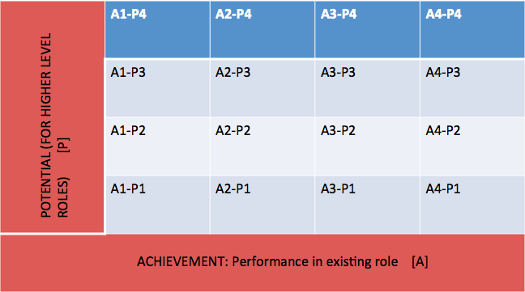

|  |  |
| --- | --- |
| P4- Employee displays clear and strong alignment with the next level role. There is a very high probability that he/she can comfortably handle a role which is even two levels higher than his/her current role, when compared to most of the peer groups in and outside the group. He/She is significantly and undoubtedly ahead when compared to the nearest peer group | P4- Outstnading |
| P3 – Employee exhibits rapid development towards the next level role and can start meeting expectations of the higher role faster than most of his/her peers | P3 - High |
| P2 – Employee exhibits reasonable development towards the next level role and can acquire the capabilities for the higher role in a reasonable period of time. | P2 - Fair |
| P1 – Employee displays inadequate capabilities towards the next level role and it is generlly difficult to visualise any significant enhancement in the capabilities in the near future | P1 - Limited |

* 1. **Assessment techniques and policy for Promotion and Development of Employees at Sutherland Global Services**

**Objective:**

* To recognize and reward, merit and competence.
* To develop existing employees to meet the future needs of the organization.
* To improve organizational and functional effectiveness.
* To provide career opportunities.

**Scope:**

* All Sutherland Employees from Level 1 & above are eligible for Promotion

**Promotion Cycle:**

* During the PDR Cycle (only once per annum)
* Any Promotions during the year will be considered only through ICP (Internal Career Posting).
* In case it is a domain specific requirement- ICP can be published which will follow the same process and has to be reviewed by PHR.

**Process:**

**Level 1-2.5:**

* A Top Performer while stack Ranked (Top 30%) and the Goal Score should be more than 3
* Minimum Tenure of 18 Months is required in the current Level
* L1 & L2 in Production should have completed CDP – Online Foundation Course
* L2.5 in Production should have cleared Behavioral Assessment & LEAD 100 Training
* L2.5 will undergo a panel interview
* Position availability and Budget availability in the Program

**Level 3 and 3.5:**

* A Top Performer while stack Ranked (Top 30%) and the Goal Score should be more than 3.5
* Minimum Tenure of 24 Months is required in the current Level.
* Level 3.5 in Production should have cleared LEAD 200 Training.
* Level 3.5 should have completed Six Sigma Training.
* L3 & L3.5 will undergo a panel interview.
* Position availability and Budget availability in the Program.

**Level 4 & above:**

* A Top Performer while stack Ranked (Top 25%) and the Goal Score should be more than 3.5
* L4 & L4.5 should have a minimum tenure of 24 Months in the Current Level.
* L5 & above should have a minimum tenure of 36 Months in the Current Level
* One Project Completion / Six Sigma Completion.
* Position availability and Budget availability in the Program.

**Formation of Assessment Centre for Promotion Purpose**

**Fast Tracker Promotions**

The above tenure restrictions will not apply for Top performers. Top performers are identified based on the following:

Level 1-2.5:

* Any employee who has completed 12 months in the same level and is in the top 5% of the stack ranking of the last 12 months KRA scores and current goal scores is considered as ‘Fast Tracker.

Level 3 - 4.5:

* Any employee who has completed 15 months in the same level and is consistently in the top 5% of the stack ranking of the last 12 months KRA scores and current goal scores.
* Apart from this a brief mention on the initiatives, achievements and any innovative practices of the employee should be sent by the manager to the PHR during recommendation.

Level 5 & above:

* Any employee who has completed 18 months in the same level and is consistently in the top 5% of the stack ranking of the last 12 months KRA scores and current goal scores.

**Assessment tools used**:

* Panel interviews for all the levels
* CDP foundation certification for level 1 to 2.5
* Top 5% performers according to the normalization curve

|  |  |  |
| --- | --- | --- |
| **Normalized Bell Curve Percentage** | | |
| **Rating** | **Normal Bell Curve %age** | **Comments** |
| 1 | 5% | Does not meet expectations |
| 2 | 15% | Meets some expectations |
| 3 | 60% | Meets expectations |
| 4 | 15% | Meets and exceeds expectations |
| 5 | 5% | Consistently exceeds expectations |